**E-mail: amitpalbcom@gmail.com**

**Contract number: Mob- +973 3446 1094**

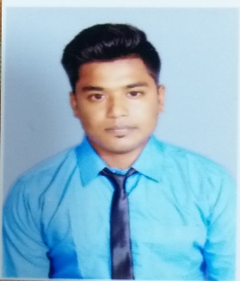

**AMIT PAL**

**EXPECTED POSITION :** **ASSISTANT COOK/COMMI 3**

**CAREER OBJECTIVE:**

* I am looking for a job as Assistant Chef in an organization where I can demonstrate my culinary skills and use my abilities for the growth of the organization along with my personal growth. I am a hardworking person who has a passion for making delicious food and loves to cook. I have a proven record of making delicious food that leaves the diners craving for more.

**Skills**

* Experience of 3 years plus working in restaurants and hotels which have a high volume of production of food
* Expert in the use of kitchen equipment that is used for the production of the outsized amount
* Can work in various shifts
* Proficient in performing basic Math’s calculations
* Ability to maintain and establish a working relationship with the management and the staffs effectively
* Effective use of grills, oven, roasters, steam kettles and knives
* Familiar with the restaurant orders and BEOs
* Skill to control and regulate the temperature while cooking special recipes
* Ability to work in the team as well as individually and manage the time efficiently
* Ability to meet deadlines and work under pressure

**EMPLOYMENT PROFILE:**

**28th November 2018 to Present**

* Company : **Pasta Express** **(Bahrain)**
* Profile : Restaurant
* Position : Assistant cook

**15 April 2017 to 20 October 2017**

* Company : **Hotel Sea Princess** **(Mumbai, India)**
* Profile : Hotel
* Position : Trainee

**EDUCATIONAL QUALIFICATION:**

* Higher Secondary Education Passed (West Bengal, India) in the year of 2011
* B.Com Graduate under **UNIVERCITY OF CULCUTTA** in the year of 2014

**OTHER QUALIFICATION**

* **Royal Institute For Hotel Management (*Diploma in F&B Production*) in the year of April 2015 to March 2017.**

**COMPUTER SKILLS:**

* Conversant with MS - Windows, MS - Office and Diploma in Information Technology.

* **PERSONAL DETAILS:**
* **Fathers name :** Debasish Pal
* **Date of Birth :** 09/04/1993
* **Place of Birth : Kolkata**
* **Religion :** Hindu
* **Nationality :** Indian
* **Languages Known:** English, Hindi & Bengali. (Read, Write & Speak)
* **Marital Status :** Single
* **Physical Appearance:** Height – 5.4’ Weight – 65Kg Chest – 34’
* **Passport Details; N7360097 - Valid up to 09/03/2026- Issued on 10/03/2016**

**Issued at Kolkata**

* **Native Address :** 128/A Kalighat Road, Kolkata – 700026, West Bengal – INDIA.

Signature of the Applicant