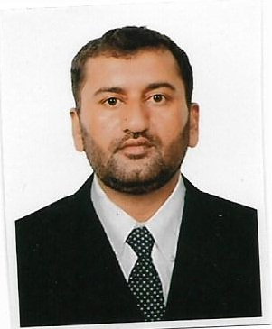 **CURRICULAM VITAE**

**SUKHWINDER SINGH**

**Kingdom of Bahrain**

Mob: 00973-36467341

0091-9417119347 / 9417119447

Email: ss8027313@gmail.com

**APPLIED FOR POST : CIVIL FOREMAN**

**OBJECTIVE:**

To work a challenging friendly organizing offering job satisfaction, where my exposure and skill can be used in the best possible way, given me an opportunity for career development based on achievement and results.

**EDUCATIONAL QUALIFICATION**

* Senior Secondary Art- 102+2 P.S.E.B ( Punjab )

**Technical Qualification**

* **I.T.I –Training Technical Institute**
* **Special Training for Fire Warden & Scaffolding From Safety marine Services(Sharjah UAE)**

**EXPERIENCE:**

* Company : **Nass Contracting Co.**

Period : 33 **months** (from Oct 2017 to till date) as *a* ***Civil Supervisor***

***Projects:***

* ALBA Interchange
* BMP- Bapco Moderization Project
* Company : **Hassan Mansoori M & I Construction (Space maker)**

Period : **4 Year** (from 2013 to Sep 2017) as *a* ***Civil Foreman till continue***

***Projects:***

* ***Proposed Service Building At Safra(Police Training centre)***
* ***Site In-charge Civil works***
* Company : **Cebarco Bahrain W.L.L in Kingdom of Bahrain**

Period : **9 Years (from 2003 to 2012)** as a ***Civil Foreman***

***Projects:***

* **Bahrain racing Circuit (Formula 1 ) 2003 to 2004**
* **See Fly Over Project Carp. Foreman 2004 to 2005**
* **Durrat Al Bahrain Road & Fly Over 2005 to 2006**
* **Bahrain City Centre Project 2006 to 2008**
* Company :**Cebarco Bahrain W.L.L in UAE**

Period : **4 Year (from 2008 to 2012)** as a ***Civil Foreman***

***Project:***

* ***Yas Marina Racing Circuit (Formula 1 )-Abu Dhabi***

**PERSONAL DETAILS:**

Date of Birth : 09- 10- 1980

Gender : Male

Marital Status : Married

Nationality : Indian

Religion : Sikh

CPR No : 801019940

Passport No : K7421489

Issue Date : 18/07/2012

Expiry Date : 17/07/2022

Place of Issue : Abu Dhabi (UAE)

Driving License : Have Valid Light vehicle License- from Bahrain

Language Known : English, Urdu, Hindi & Panjabi

**DECLARATION**

I hereby declare that the above mentioned information’s are true and correct to the best of my knowledge and belief.

**SUKHWINDER SINGH**