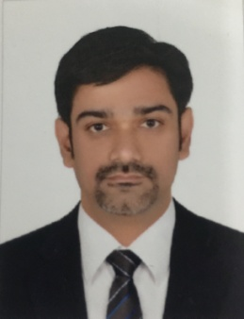**VAJRA BAHU C R**

G-1,BUILDING NO. 722

GAFOOL, MANAMA, BAHRAIN

**+973 3563 9585**

VAJRABAHUCR@GMAIL.COM

**Professional Summary**

Talented Sales professional effective at multi-tasking and reaching sales targets.

Builds loyalty and long-term relationships with customers. Sales Person who

Supplies customers with the latest facts, figures and trends in the market.

**Skills**

* Goal Oriented
* Motivated Team Player
* Positive and upbeat
* Reliable

**Work History**

­­­­­­­

September 2019 **Xpress Money Services Ltd.** Bahrain

- **Senior Relationship Manager**

Current

* Build the agent network through new acquisitions
* Maintain relationship with the agents and perform continuous follow ups on various issues to ensure effectiveness in operations and maximize revenue.
* Monitor and assist the agents to achieve targets fixed for them
* Train agents and liaise with the Operations Team for activation of New Agents
* Executing branding plans/coordinates at agent partner outlets
* Collect Agent feedback, competitor information & schemes and escalate to the senior management.

December 2014 **Abu Dhabi Commercial Bank** Dubai

* **Relationship Officer**

August 2019

* Advising HNI clients on Personals Loans & Investments.
* Sourcing Privilege Customers with a cross ratio of 3 products.
* Maintaining good relationship with the Companies to manage their payroll accounts.

**Achievements**

* + - Topper in Personal Loans & Credit Cards for JFM contest in the year 2016
    - Top Performer in Credit Cards for the month of October, 2018

August 2011 **HDFC Bank**  Kochi

* **Personal Banker**

November 2014

* + - Managed Classic Portfolio of the Bank consisting of 200 HNI groups.
    - Cross Selling of Term Deposits, Investment Products and TPP products.
    - Sourced and Managed NRI & Residents HNI CASA relationships.

June 2010 **IIFL** Kochi

- **Sales Manager**

May 2011

* + - Supervised a Sales force & Dealing team consisting of 10 members.
    - Tracked the team on daily basis to achieve sales targets as well as revenue targets.

July 2006 **Kotak Securities Ltd**  Kochi

- **Business Development Manager**

September 2009

* + - Sourced HNI clients who can invest into Equity Portfolios.
    - Maintained long term relationships with HNI clients to generate revenue.

**Achievements**

* + - Could become No. 2 in the South India Top Performers’ list in the year 2008-2009
    - Could become No. 1 in the South India Top Performers’ list in the first quarter of 2009-2010

**Education**

2006 **M G University** Kerala

**M B A in Marketing & Finance**

2002 **M.G University** Kerala

**B.Com**