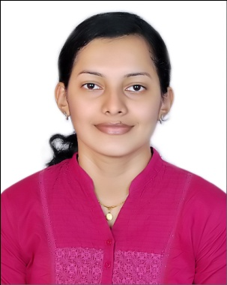**Andrea Renisha Suares**

**Mobile: 00973 66645546 / 38075599**

**Email:** [**suaresandrea21@gmail.com**](mailto:suaresandrea21@gmail.com)

**Current location : Bahrain**

**------------------------------------------------------------------------------------------------------------------------------------------**

**Objective: Secure a responsible position, sharing my 6 years of experience in HR operations and secretarial practices, administrative work, performance management, talent management and employee engagement framework, along with interpersonal skills and an ability to work across multiple stakeholders to further the growth of the company*.***

**Job Experience IT People Gulf, Bahrain (Recruitment Consultant June 2019 to present**

* Recruitment all over the GCC| Screening |Sourcing |Organising interviews |Customer Satisfaction |Client Handling |Account Managing.

**Robosoft Technologies Ltd (HR Executive Feb 2017 to Mar 2019)**

* + - * **HR Operation:** Induction | On boarding |Employee file management |Leave Management |Performance Management |Employee engagement| Payroll management.
      * **Talent Management:** Sourcing talent |Training & Development| Retention |Promotion | Performance appraisal |Career Planning |Exit Management.

**Manipal Technologies Ltd (Executive Secretary & HR Jun 2014 to Nov 2016)**

* Drafting letters| Memo| Maintaining legal documents |Induction and on boarding | Confidentiality| Leave and travel management| Performance management |Employee engagement| Statutory compliance |Exit management | Petty Cash Management| Payroll Management.

**Veta English Training Academy, India (Customer Service & Admin Executive-Jun 2013 to May 2014)**

* Handle front office| Greet and provide the information on service| Handle administration duties | Answering phones| Handling company enquiries| Sorting and distributing mails.

**Education**

* Master of Business Administration from Sikkim Manipal University (2013)
* Bachelor of Computer Application from Mangalore University (2010)
* Certificate course in office administration and secretarial practice (2011)

**Skills** Microsoft office| Communication| Conflict management |Decision making |Ethics |Organizing| Policies & Procedures| On boarding| Performance Management| Technical Recruiting| Induction| Strategic Planning| Employee relation| Talent Management| Training & Development| Payroll Management| Employee grievance| Time Management.

**Personal Details** Father Name : Lt. Denis Suares

Mother Name : Ancilla Suares

Date of Birth : 21/12/1989

Marital status : Single

Nationality : Indian

Passport Number : S4862531

CPR : 891262431

Languages : English, Hindi, learning Arabic

**DECLARATION**

I hereby declare that all information furnished above is correct to the best of my knowledge.

……………………....

(Andrea Suares)