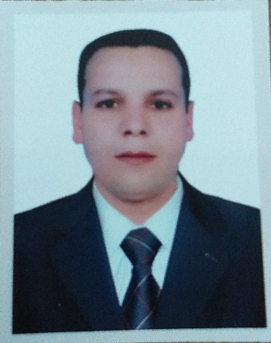

**Ramadan Ragab Khalaf**

**Location**: Bahrain

**Mobile**: Bahrain 009733353134 / Egypt 002 01229787656

**E-mail:** [**ramadanaljarhy49@gmial.com**](mailto:ramadanaljarhy49@gmial.com)

**Profile**

|  |
| --- |
| Qualified and confident professional with over 12 years of experience in hotels industry, at different levels of responsibility. Skilled at work with a diverse of group of people and Possess Strong customer service and communication skills. |

**Core skills**

* **Languages**: Arabic / English
* **Interpersonal skills:** Having a friendly attitude, able to develop a good rapport and connection with guests and able to make people feel at ease right away.
* **Attention to details:** A good observant, able to monitor deliveries, building premises and everybody coming in.
* **Customer service**: Committed to creating excellent customer experience and answering all inquiries thoroughly.
* **Physical stamina**: Able to stand for several hours regardless the weather. Able to handle and carry heavy bags.

**Education**

* Institute of industrial diploma.

**Career Summary**

|  |  |
| --- | --- |
| **Four seasons hotel Bahrain**  **Job title : Guest services doorman and shift leader** | **2015 – 2020** |

**Key Responsibilities.**

* Managing the man power in the shift and distribute responsibilities between them.
* Answering any guest’s inquiries.
* Greeting and receiving the hotel visitors and identifying the reason of their visit.
* Directing the visitors to their right destination.
* Receiving and counting the luggage of the guests upon check in and directing guests to reception.
* Escorting the check in guests to the reception.
* Receiving the cars from guests and check the condition of the car before parking it.
* Arranging the process of parking the cars with valet parking employees.
* Arranging the process of luggage pick up for the check out.
* Ensuring the guest’s car is ready upon check out.
* Checking with the guest to ensure his luggage is complete upon check out.
* Confirming with the guest upon departure to ensure no missing belongings or papers.
* Handling the break time for the staff members in the operation according to the work volume.
* Preparing the weekly staff roster.

|  |  |
| --- | --- |
| **Four Seasons hotel Riyadh** | **2011- 2015** |
| **Job title: Doorman** |  |

**Key Responsibilities.**

* Greeting and receiving the hotel visitors and identifying the reason of their visit.
* Directing the visitors to their right destination.
* Receiving and counting the luggage of check in guests and giving guests a card with the same count.
* Escorting the check in guests to the reception.
* Receiving the cars from guests and check the condition of the car before parking it.
* Arranging the process of parking the cars with valet parking employees.
* Arranging the process of luggage pick up for the check out.
* Ensuring the guest’s car is ready upon check out.
* Checking with the guest to ensure his luggage is complete.
* Confirming with the guest upon departure that no belongings or papers are left behind.

|  |  |
| --- | --- |
| **Four Seasons hotel Riyadh Job title : Bellman** | **2008-2011** |

**Key Responsibilities.**

* Delivering the guest’s luggage to the room after check in.
* Ensure to address the guest by name in any interaction.
* Placing the luggage in the room according to the guest’s preferred location.
* Offering the guest our laundry service during check in and inform him with laundry service time.
* Giving the guest a detailed orientation about the room set up and facilities.
* Picking the guest’s luggage for check out.
* Count the guest’s luggage before check out and reconfirm the count with the guest.
* Offering the guest to arrange transportation if he does not have his personal car.
* Reminding the guest to check for any forgotten belongings before check out.

|  |  |
| --- | --- |
| **Four Seasons hotel Doha - Qatar Job title : Room attendant** | **2005-2008** |

**Key Responsibilities.**

* Clean guest rooms according to standard.
* Ensure to complete all assigned rooms by the end of the shift.
* Connect with guests when possible to get their feedback and preferences and report it.
* Clean guest corridors.
* Working in all shifts morning, afternoon and night shift.
* Using all machines in the department for marble and carpet cleaning.
* Report any maintenance issues required.
* Maintain back area organized and in good shape.
* Report any work challenges to the direct supervisor.
* Follow hotel security procedures**.**

**Key achievements**

* Contributing to enhance the score of guest comment cards.
* Contributing to enhance the number of returning guests through the outstanding service.
* Deriving a lot of thanks and recommendation letters from guests.
* Getting the award of employee of the month in several occasions.
* Getting the honesty award for returning guest’s valuable items in several occasions.

**Training and workshops attended**

* Manager of the future training workshop.
* Coaching and feedback workshop.
* Communication skills workshop.
* Conflict management workshop.
* Change management workshop.

