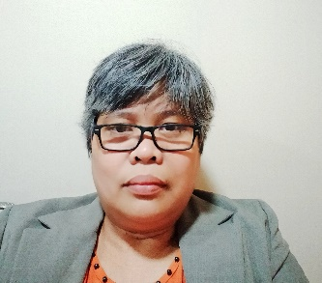

**EMILY ROMEO REPASO**

Manama- Kingdom of Bahrain

+97339615698 / +97336564111

[melgrate94@gmail.com](mailto:melgrate94@gmail.com)

**Objective:**

To be part of fast pace industry wherein I can apply new learning techniques, fresh ideas on human relations and to exhaust my talents and abilities.

**Employment Background**

**1. Document Controller**

Mazen Alumran Consulting Engineers

Cyprus Cybarco Tabet JV WLL (Employed by)

January 13, 2019 up to present

**2. Accountant**

HKH Contracting SPC - Manama, Kingdom of Bahrain

January 2016 to October 2018

**3. Accountant Cum Receptionist Cum Secretary - Reliever**

Bright Home Contracting – Sanabis, Manama

September 2015 to December 2015

**4. Accountant Cum Receptionist Cum Secretary - Reliever**

Creativity Secrets Décor – Budaiya, Manama

June 2015 to August 2015

**5. Accountant Cum Receptionist Cum Secretary - Reliever**

ALSHUHUB CONTRACTING – Budaiya, Manama

March 2015 to May 2015

**6. Accountant Cum Receptionist Cum Secretary - Reliever**

Arion Autos Partnership Co. - Manama

April 2014 to February 2015

**7. Receiving Staff/Receptionist/Purchasing**

Foods Saversmart Corp. - Cebu City

June 2002 to April 2007

**8. Cashier**

Robinson's Supermarket - Cebu City

April 2001 to April 2002

**9. Cashier**

Robinson's Department - Cebu City

July 2000 to January 2002

**10. Laboratory Assistant**

Shemberg Corp. - Cebu City

April 1998 to January 2000

**11. Sales Associates/ Jag Jeans**

Gaisano Department Store - Iligan

March 1994 to April 1996

**12. Accounting Clerk/Bookkeeper**

Bureau of Internal Revenue - Iligan

May 1992 to August 1993

**Personal Information:**

Birth Date: April 18, 1973

Birth Place: Sindangan, Zamboanga Del Norte, Philippines

Sex: Female

Civil Status: Married

Religion: Roman Catholic

Nationality: Filipino

**Education**

**College/University:** **Junior Secretarial Course in Computer Science, Secretarial**

Saint Peter's College – Iligan, Philippines

1990 to 1992

**High School: Iligan City National High School**

Iligan City, Philippines

1986 to 1990

**Elementary: South I Central School**

Tubod, Iligan City, Philippines

1980 to 1986

**Character Reference**

**William Hanania – Sr. Project Manager**

Cyprus Cybarco Tabet JV W.L.L.

William.hanania@cct-bh-com

**R.P Selvam – Resident Engineer**

Mazen Alumran Consulting Engineers

sr.civil2@mazenalumran.com

I hereby signed that the above information is true and correct to the best of my knowledge and belief.

**Emily Romeo Repaso**