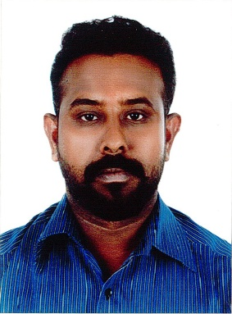**Career Objective**

Seeking for a suitable position in a company that will further enhance my skills and Knowledge to be become an effective member of the company and contribute to its success and development.

**Personal Details**

|  |  |
| --- | --- |
| **▪** Date of birth | 13/06/1988. |
| **▪** Sex | Male |
| **▪** Nationality | Indian |
| **▪** Marital Status | Married |
| **▪** Hobby | Movies, Net Surfing, Listening to songs |
| **▪** Contact Details | Email Id: sathishmuthu401@gmail.com  WhatsApp No: 0097333381775  Mobile No: 0097438924599 |

**License Details:**

License No : 880615907

Issue Date : 10/12/2012

Expiry Date : 09/12/2022

**Educational Qualification:**

|  |  |
| --- | --- |
| **▪** 10th Standard |  |

**Languages Known**

* Tamil, English, Hindi & Malayalam

**Work Experience**

* 3 Years worked as a driver at Yatim Air conditioning W.L.L, Bahrain
* 1 year worked as a driver at Kafath Food Stuff, Bahrain
* 4 years worked as an A/C Assistant, A/C Insulator at Yatim Air conditioning W.L.L, Bahrain
* 1 year 10 months as driver with salesman SADIQ MOHSIN ISA SALEH ESTABLISHMENT

**STRENGTHS**

* Self Confidence, Interpersonal Skills, Hard Working, Volunteering to responsibilities

I hereby declare that all the above mentioned particulars are correct and true to the best of my knowledge and belief.

**Sathish Muthu**