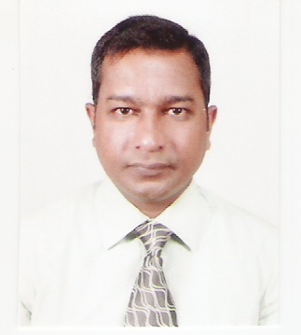

Dear Sir/Madam,

**ANY SUITABLE POST IN FINANCE OR ACCOUNTING**

I submit herewith my resume for your kind review and consideration.

In brief I am a passed finalist of institute of chartered accountants of Sri Lanka with a degree in bachelor of commerce and having over 20 years of experience to my credit in varied business sectors including hospitality, telecommunication, manufacturing and trading industries. Employed at Cocoon Maldives & You&Me by Cocoon (since pre-opening) in Maldives as Corporate Financial Controller and currently engaged in Best Western Elyon, Sri Lanka as Financial Controller. Looking forward for a better opportunity.

I have acquired vast experience in finance, auditing, administration, sales & marketing, accounting software, ERP, spreadsheet skill in MS Excel and reporting in MS Word.

-Managing the company’s financial accounting, monitoring and reporting.

-Overseeing the quality and accuracy of the accounting, payroll and payment processing services.

-Liaising with auditors in producing annual financial reports.

-Providing and interpreting financial information and predicting future trends.

-Conducting reviews and evaluation for cost reduction opportunities.

-General financial administration.

-Closely monitor the expenditures and receipts and submit reports to the top management on a daily, weekly and monthly basis.

-Procurement and supplier management, including selection, appointment, and management of key vendors and office infrastructure providers.

My primary success factors are honesty, professional integrity, assuming responsibilities with a positive adaptation to the corporate mission of the company and carryout duties with diligence, dedication and commitment towards the achievement of corporate goals.

If you wish to contact me please call me on phone 0094 773388000, email to [msirajsha@yahoo.com](mailto:msirajsha@yahoo.com) or Skype (mohamed.siraj.shahabdeen).

Thanking you.

Sincerely,

**Mohamed Siraj Shahabdeen**