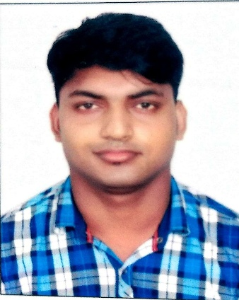 RESUME GANESH CHANDRA MOHANTY

gmohanty202@gmail.com

**VOICE- +973 33598542**

**ADRESS- PADHANI ,DHAMANGAR,BHADRAK ,BHUBANSWAR, ODISHA**,

**OBJECTIVE: To join in a suitable hospitality industry which offers me an opportunity to continuously learn & evolve myself not only as a better professional but also as a better person.**

**PROFILE :**

**I have almost 5 years experience in the hospitality industry at India with additional exposure to operation and customer service in highly professional environment. I posses a Strong sense of professionalism and efficiency in a rapidly changing environment Some of key behavioral and leadership qualities .An effective team member with strong problem solving skills,**

**EDUCATION:**

* **Passed out 3years Diploma Hotel Management from CIHMC , Bhubaneswar. -INDIA- 2012-2015**
* **Passed out Intermediate(+2) with commerce from council of higher secondary education ,Bhubaneswar, Odisha, INDIA 2012**
* **Passed out Matriculation(10th) from Board of secondary education, Cuttack, Odisha, INDIA .2010**

**Training/Courses**

* **Successfully completed short term course ( FOOD RESEIVING &FOOD SERVICE&FOOD PREPARATION ) at FOUR POINTS BY SHERATON**

**MUMBAI, INDIA**

**Achievement:**

* **Deputed in various food festivals and promotions during the three-year Diploma in Hotel Management*.***
* **Basic food safety training**

***PASSPORT DETAILS.- M 7799112***

**EXPERIENCE:**

**PRESENTLY I AM WORKING WITH THE ALSHAYA CO. ,IN DEAN&DELUCA AT THE AVENUE ,BAHARIN AS** A **CHEF DE PARTIE FROM 20SPT2017 TO TILL DATE**

* **Prepare and service all food items according to restaurant recipe in standards**
* **Ensures consistency in test and presentation of all food items**
* **Maintain daily mis-en-place and prepare creation food items for the following days duties**
* **Has the ability and fix ability to basic schedule for opening and closing shift**
* **Ensure food is stored and cooked at correct temperature by regulating temperature of ovens, boiler ,Grills and roasters**
* **Monitors related equipment reporting any problems for inconsistencies to the sous chef**
* **Performs other related duties as required**
* **Helping the sous chef and head chef to develop new dishes and menus**
* **Preparing, cooking and presentation dish within your specialty**
* **Ensuring the team have following high standards of food hygiene and rule health and safety**
* **Monitoring portion and waste control to maintain profit margins**

**WORKED WITH THE HOTEL ROYAL ORCHID , NAVI,**

**MUMBAI ,INDIA**  AS A **COMIIS CHEF FROM**  22 FEB 2016 TO 18SPT2017

* **In - Store trainer hot range section.**
* **In charge keeping eye on food storage and its shelf -life, with production batch nos and their day dots**
* **Specialization in sauté, broil and salad section.**
* **responsibility for hygiene, maintenance in the Kitchen.**
* **Wastage controls.**
* **checking all the temperature of freezers**
* **keeping the FIFO& LIFO**
* **Maintain daily mis-en-place and prepare creation food items for the following days diuty**

**WORKED WITH HOTEL FOUR POINTS BY SHERATON , NAVI MUMBAI,INDIA AS A COMMIS CHEF 12TH JUNE 2015 TO 15TH DEC 2015 ).**

* **Indenting portion control.**
* **Communication with senior chefs if need**
* **Pickup daily store for continental kitchen department**
* **Helping to senior chefs for making continental dish preparation**

**SHORT- TERM ASSIGNMENT :**

**WORKED WITH HOTEL FOUR POINTS BY SHERATON NAVI MUMBAI , INDIA AS A TRAINEE 20TH SEP 2013 TO 1ST FEB 2014**

**AREA OF INTEREST: CONTINENTAL CUISINE**

**PERSONAL DETAILS** :

**Father's Name : Mr. Digambar Mohanty ,**

**Height & weight : 5'07" .68 Kgs**

**Languages : English ,Hindi, odia**

**Hobbies : Listening to Music,**

**Date of Birth : 02/07/1994(d/m/y)**

**Marital status : Single**

**Religion : Hind**

**Declaration** I hereby declare that the above written particulars are true to the best of knowledge and belief.

DATE…… GANESH CHANDRA MOHANTY

PLACE... Manama, Baharin