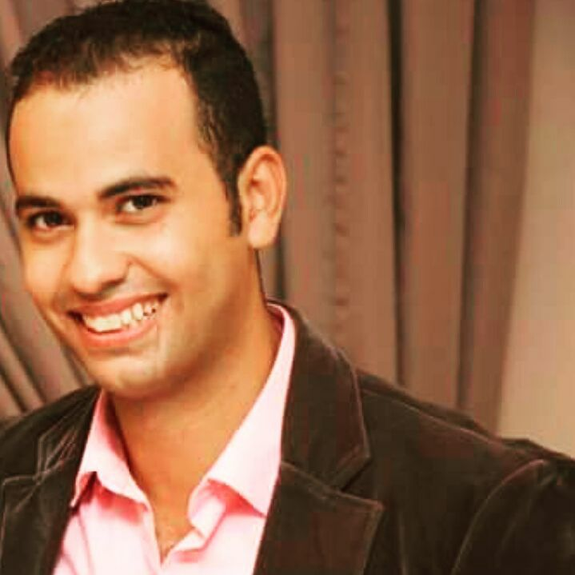

**Location:** East Riffa/Bahrain  
**whatsAppNumber:** 00201274502722   
 **Bahrain number:** 0097338289709

**Email:** [chef.khaledsamir@gmail.com](mailto:chef.khaledsamir@gmail.com)

# Khaled Samir Attia Mahmoud

**OBJECTIVE** Seeking a permanent position with a reputable firm, to become part of the team in an interesting business with considerable growth potential, where I could develop continuously, and where my qualifications and experience in Industry would contribute to the corporate success.

**SKILLS &ABILITIES**

Computer Skills - Microsoft Word, Excel, Internet, Power Point, Excellent Knowledge of hardware and software.

Languages –English very good command of both written and spoken English, Arabic (Mother Language)

**Course:**

* Diploma in NGC, (HR) from Ain shams University.
* Certificate of participation for attending the Sauces workshop from the Egyptian Chefs Association.

**Personal Skills:**

* Ability to work effectively under pressure with positive attitude.
* Ability to learn new tasks quickly.
* Excellent communication and negotiation skills.
* Strive for continued excellence.
* Active personality and self-confident.
* Highly motivated.
* Ability to learn advanced technologies.
* Ability to work in team.
* Excellent customer focus
* Good listening and critical reasoning skills.
* Handle multiple scopes of tasks of user acceptance tests; internal & external service level agreement.
* Result oriented.
* Flexibility in multi-tasking

**EXPERIENCE:**

The Gulf Hotel Bahrain Convention & Spa (CDP) “Chef de Partie” **September 2018 till September 2020**

Responsible for the main Kitchen; Managed the Deck restaurant single-handedly. Prepared, cooked, and presented dishes; assisted the sous chef and head chef to develop new dishes and menus.

Managed and trained commi chefs and new chefs. Ensured high standards of food hygiene; followed the rules of health and safety. Monitored portion and waste control to maintain profit margins.

* Safety food in catering (HACCP).
* Cooking method.
* Making good items by full the recipe.
* How to make food cost and menu planning.
* Prepare Pastry & bakery cook.
* Handling Fish and shellfish, meat, poultry
* **Working as Chef De Partie at (la pergola restaurant) for 2 years at Gulf Hotel Bahrain Italian cuisine with Italian Chef who has two Michelin stars.**

Hilton Towers Heliopolis (Demi Chef de Partie) **february2018Till August2018**

Have experience for 1 years of French cuisine as Demi Chef De Partie (Le-Marche Restaurant) Hilton Towers Heliopolis

* Responsible for all sautéed items and their sauce.
* Prepares roasted and braised meats and their appropriate sauce.
* Prepares all grilled foods.
* Prepares hot appetizers and often prepares the soups, vegetables, pastas and starches. In smaller establishments.
* Responsible for preparing cold foods including salads, cold appetizers.

Fairmont Towers Heliopolis **July2017Till february2018**

Have experience for 2 years of Italian cuisine as Demi Chef De Partie ( Leonardo Restaurant ) of Fairmont Towers Heliopolis.

* Write stores and make schedule for every week ….
* Make good presentations for all items to be perfect.
* Make guest happy about our cooking by eating delicious dishes.

IHG (InterContinental city stars)  **October 2016 Till November 2016**

## Commie1

Fairmont Towers Heliopolis **December2015Till September 2016**

## Commie1

Coral Seahot kitchen (*Commie2*) **2013till 2014**

Americana Sweet **From 2003 to July 2007**

## *Bakery*

EDUCATION

* Bachelors of tourism and hotel (Degree) of Hotel management since 1/7/2012.
* International Semester from CTC at cooking certified from (City & Guild) since 10/12/2015.
* Culinary Training Centers Egypt (CTC)**April 2015 till December 2015**

INTERESTS: Reading books, Swimming, Golf, Basketball

REFERENCES: FURNISHED UPON REQUEST

