# MOHAMMED REZAUL KARIM

House NO: 1051# Road No #5122

Block No#351

Al Burhama,Kingdom of Bahrain

CONTACT No: +973 36863134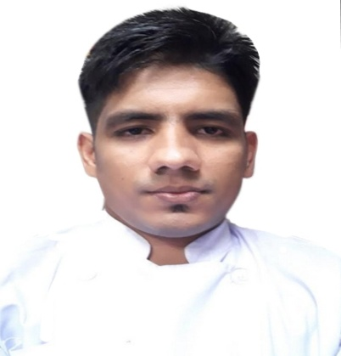

Emai[l: sohelisfahani055@gmail.com](mailto:l:%20sohelisfahani055@gmail.com)

# OBJECTIVE

* To find challenging position to meet my skills, competencies, capabilities, education and experience

# PERSONAL INFORMATION

* Date of birth : 15th April 1988
* Gender : Male
* Religion : Muslim
* Marital status : Married
* Nationality : Bangladeshi

# JOB EXPERIENCES

* Isfahani Restaurant Bahrain (May 2014 to Till Date )

*Kitchen Assistant Chef

-In charge on division of kitchen staff to have a good working flow

-Do any task that needing help; Versatile job

-Make Stock Request and maintain the availability of all kitchen items

*Salad Maker

-Do all job in salad area such as order of appetizers or salad

-maintain cleanliness area

- Help other area if have vacant time

*Butcher

-Prepare all meat items such as kebab, shishtawook, etc. (cutting, marinating, mixing and all necessary works)

-Do grilling

-Maintain cleanliness of area

* The peninsula Chittagong Bangladesh (January 8, 2010 march 2, 2011)

*Commissary 1

-Maintain cleanliness of area

Do task that executive chef assigned such as garnishing, cooking, butchery work or salad

## EDUCATIONAL ATTAINMENT

* Higher Secondary School: Mostafa hakim Degree collage 2006-2008

## Secondary School: Moshajidda High School 2004-2006

## LANGUAGE

* + English
  + Arabic
  + Hindi

## STRENGTH

* Versatile
* Can work under pressure
* Work dedicated
* Open-minded

## REFERENCES

Asghar Arjmand

Former: Isfahani Head chef Bahrain Presently: Arjmand cafe

Executive chef owner Iran