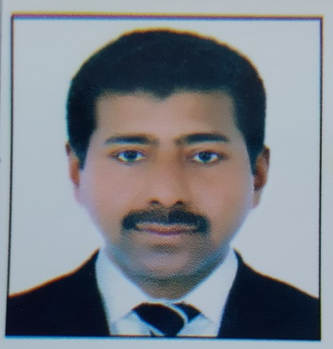***CURRICULUM VITAE***

***Eruppakottil Muhamed Nizar***

***E & I department***

***BAHRAIN STEEL***

***P.O.Box: 50177***

***Hidd, Bahrain***

**Mobile # 00973 33741288**

**Email : rubynizar@gmail.com**

**Sub: Post applying for ELECTRICAL TECHNICIAN.**

**Career Objective:**

Seeking for a challenging job in an organization, where my skills and experience can be shared and strengthen. An opportunity where I can utilize my communication and technical skills would be an additional pleasure. Eventually I would like to be one of the productive assets of the organization.

**Professional Qualifications**:

NCVT Diploma : Obtained from Government of Kerala.India

**(Electrical)**

***Professional Skills****:*

Routine maintenance and trouble shooting of all electrical and instrument equipments such as HT.,LT motors, motor control centers, breakers, starters, frequency drives, transformers, slip ring induction motors, synchronous motors, fire alarm systems, devicer net, control net, ethernet and PLC controlled MCC and breakers.

HT vector control drives of Robicon Siemens and Allen Bradley up to 5600KW,

LV variable frequency drives of Siemens master drives, micro master and ABB& SEW Movie drives.

*[Page 1 of 3]*

Field instruments such as speed monitors, emergency pull chords, Sway s/w and level s/w, transducers, pressure switches, flow meters, temperature sensors, pneumatic valves, weigh feeders, silo level sensors, all type of safety instruments of industrial equipments, UPS etc. Fuel oil and gas control systems.

Liquid resistance and oil immersed resistance starter maintenance.

Centralized control plant operating systems and battery systems etc. Laying & Termination of control and power cables up to 4 x 400mm² and HT cables up to 300mm² .

Worked on PLC S5 and S7 DCS system in Siemens and Cemat & WINCC operating Stations.

Also familiar in relay logic control systems.

Preparing all maintenance records monthly & yearly shut down plans.

**Employment Experience**:

**Present working** : **BAHRAIN STEEL (**largest steel manufacturing

Company in bahrain)

Designation : **Electrical Technician**

Period : From Nov.2011 onwards

***Job Responsibilities* :***A*ll kinds of jobs related to installation, commissioning of Electrical Equipments

***Organization served*** : **GULF CEMENT COMPANY,** Ras Al Khaimah,

UAE.

## Company Profile : This Company is pioneer in UAE for Cement

## Manufacturing (**POLYSIUS,GERMANY**

## **THYSSENKRUPP&UBE Japan plant**)

#### Reporting to : Electrical Engineer

Designation : **Electrical Technician**

Period : From Sep. 1996 to Sep 2011

***Job Responsibilities* :***A*ll kinds of jobs related to installation, commissioning of Electrical Equipments

***Organization served* :**Fertilizers and chemicals Travancore Ltd.

Kerala.

*[Page 2 0f 3]*

## Company Profile : Fertilizer manufacturing

## 

## Reporting to : Electrical Engineer

Designation : Electrical technician

Period : From 1990 to 1991

***JobResponsibilities:*** *A*ll kinds of jobs related to installation, maintenance trouble shooting & calibration of all kinds of field instruments and electrical HT & LT cable termination & commissioning.

***Organization served*** : Cochin Refineries Ltd.

## Company Profile : Crude oil refining in Kerala.India

#### Reporting to : Electrical chief Engineer

Designation : Senior Electrician

Period : From 1991 to 1996

***Job Responsibilities :*** *A*ll kinds of jobs related to installation, maintenance,trouble shooting, and power synchronization

**Personal Details**

Father’s Name           :  Muhamed E.H,

Date of Birth                 :  13-04-1972,

Marital Status               :  Married,

**Contact No** : 00973-33741288

**Email**  : rubynizar@gmail.com

**Passport No.              :** N8033354

**Driving License : Having valid BAHRAIN license**

*[Page 3 of 3]*