**Rafia Alkobaisi**

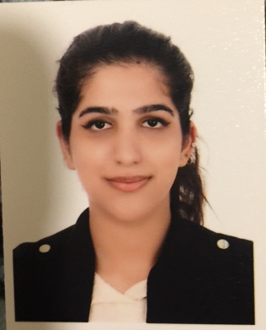

<Tel:(+973)-33529851>, E-mail:rafiahashel@gmail.com

Saar, Bahrain

**Personal Profile**

To enhance my educational and professional skills in a stable and dynamic work place.

To build a long term career in Hospitality with opportunity of career growth.

**Education**

**July 2018 – present** Diploma in Hospitality and Tourism Management

Bahrain institute of hospitality and retail

**2015-2016** The Westminster School ,GEMS Education Dubai, UAE

International general certification in secondary education

**Experience**

**July 2019 Present**

**Chef commi 3- Wyndham Grand Manama**

* Interact with guests on daily basis
* Come up with unique ideas in food and beverage industry
* Achieve the best outcome
* Provide creative dishes

**Apr 2017- Dec 2017**

**Customer Service Representative- Etisalat**

* Confer with customers by telephone or in person to provide information about products or services, take or enter orders, cancel accounts, or obtain details of complaints.
* Keep records of customer interactions or transactions, recording details of inquiries, complaints, or comments, as well as actions taken.
* Check to ensure that appropriate changes were made to resolve customer problems.

**Jan2016-Mar2017**

**Receptionist – Umniah real estate**

* Ensuring all the work is processed on time
* Dealing with potential clients politely and engaging well
* Provide excess aid to all customers and resolve all issue
* Handle situation with great manner

**Oct2017-Feb2018**

**Hostess-WIEF**

* Aid guest with the event information and greet them.
* Hand out the brochure and event catalogue.

**Apr2017-Jan2018**

**Trained by celebrity chef-Capital club, 2 Michelin starred chef Paco rencero**

* Learn new recipes
* Develop unique skills and creativity
* Adapt ideas about different cultural cuisine
* Learn new cooking skills according to the origin

**January-2019**

* Certificate of attending “Chef Services”

with Celebrity Chef ‘Paco Roncero’

at Capital Club Manama - Bahrain

**October-2018**

* Certificate of attending “Chef Services Italian Cuisine”

With Celebrity Chef ‘Daniel Galmiche’

At Capital Club, Manama –Bahrain

**April – 2018**

* Certificate of Attending“Contemporary British Cuisine”

With Celebrity Chef Adam Byatt

at Capital Club, Manama -Bahrain.

**STRENGTHS**

* Adaptability
* Handling pressure
* Critical thinking
* CustomerSatisfaction
* Communication
* Multitasking
* Self-motivation
* Work under pressure
* Problem solving
* Foreign language.

**LANGUAGES**

* English
* Arabic
* Urdu

**Personal Information**

* Nationality : Bahraini
* Marital status : Single
* CPR No. : 971013250

**References**

**Dr Sheryl Viegas**

Program leader

Bahrain Institute of Hospitality and Retail

Email: [Sheryl.viegas@bihr.com.bh](mailto:Sheryl.viegas@bihr.com.bh)

**Mr. Godofredo Rojo**

Assistant Professor

Bahrain Institute of Hospitality and Retail

Email: [Rojo.godofredo@bihr.com.bh](mailto:Rojo.godofredo@bihr.com.bh)