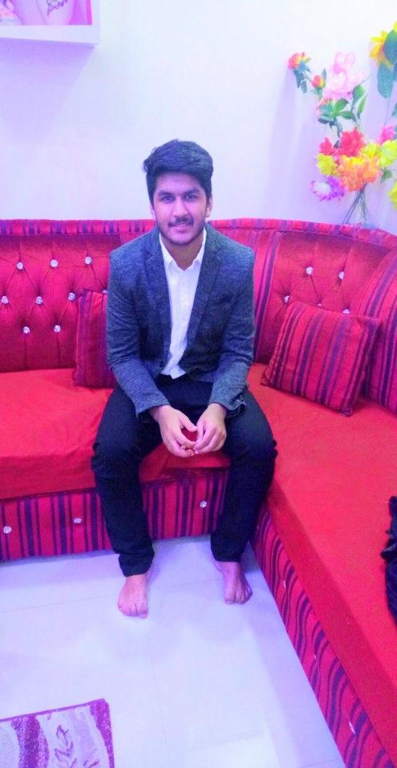 Email: [bm35916434@gmail.coM](mailto:bm35916434@gmail.coM)

Phone: (973)– 39861299,33660642

**PERSONAL PROFILE:**

**CPR: 001111434**

**Date of Birth: 27/ November/ 2000.**

**Religion: Islam**

**Nationality: Bahraini**

**Marital Status: Single.**

**Resident Address: East Riffa, Bahrain.**

**CAREER OBJECTIVES:**

Seeking an entry-level position in a reputed organization, which appreciates professional approach hard work/ fast-learning, where I can utilize my knowledge, Various Skills and experience in contribution towards fulfilling the company growth objectives, develop my career.

**EDUCATION:**

**Studying: Bachelor's Degree**:

**Banking and Finance**- UNIVERSITY OF BAHRAIN

Major**: Finance**. Minor: **Economics**.

**2018- Intermediate in Commerce**: HSSC from PAKISTAN SCHOOL BAHRAIN

**2016- Matriculation**: SSC (**Computer Science**) from PAKISTAN SCHOOL BAHRAIN

**COMPUTER SKILLS:**

* Good Searching Skills on Internet.

**Microsoft Word:**

**Microsoft Excel:**

**Microsoft PowerPoint**:

**Internet Skills &**

**Social Networking**

**ACTIVITIES & CERTIFICATES:**

* Attended "Business and IT Symposiums" at University of Bahrain.
* Attended "Career Success" program at University of Bahrain.
* INJAZ program Bahrain.
* Attended "CV workshop" at UOB.
* Attended "Workshop at BIBF" Bahrain institute of Banking & Finance.
* Attended “Workshop at ALBA” Bahrain.

**ADDITIONAL SKILLS & HOBBIES:**

* Honest,
* Hardworking,
* Fast Learner,
* Keen Observer,
* Love Sports (Football)

**LANGUAGES:**

* English :
* Urdu:
* Arabic:

**REFERANCES:**

* Available on Request.