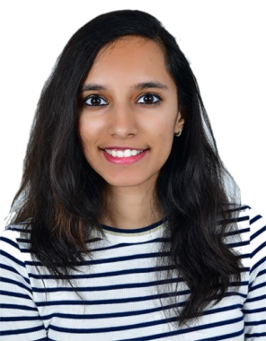

+973 38298730

Adliya,Bahrain

[Shreyaparvathy3@gmail.com](mailto:Shreyaparvathy3@gmail.com)

Driving License Available

sHREYA PARVATHY

|  |  |  |
| --- | --- | --- |
| Objective |  | Looking for work with an established firm where I can help company prosper while advancing my skills in this field. |
| PROFESSIONAl Skills |  | Tally: Intermediate  MS Office: Intermediate  Languages: English, Malayalam, Hindi and basics of French. |
| Skills |  | 1. Excellent Written and Oral communication skills 2. Exceptional ability to deal with stress and pressure   3) Strong ability to work independently as well as in a team –oriented basis |
| Work History |  | 1) Accountant Worked as an accountant in a small firm and made balance sheets. 2) cASHIER Worked as a cashier in DaVinci Franchise from 2018-2019. |
| Education |  | ACCA, KINGPINS ACADEMY, Juffair (present) Currently doing the 2nd, 3rd and 4th papers. Bcom, Indian ACADEMY, um-al hassam (present) Doing my second year from home with the help of tuitions. |
|  |  |  |