Curriculum Vitae

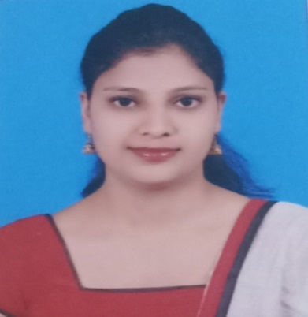**KEERTHI PRIYA PEREIRA**

**Address**

Manama, Kingdom of Bahrain

Mobile no – 00973-39096099 / 00973-34073138

Email id – [keerthi.spt92@gmail.com](mailto:keerthi.spt92@gmail.com)

**CAREER SNAPSHOT**

**Objectives:**

Iam looking for a challenging and rewarding position with potential for career advancement and long term association. Iam willing to face the challenging avenues of my job, wherein my knowledge, experience and administrative skills will help in the reputed organizations growth.

**Experiences:**

* 03 years of work experience at Kannur International Airport as **High Profile Customer Service Executive at Indigo Airlines.**
* Worked at St. Sebastian College as a B.com lecturer for 7 months.
* Delivered Guest lecturer for the period of one month in Taxation to students of Coorg National College Gonikoppal in the year 2014-2015 (MBA).

**Qualification:**

M.com -St. Agnes College P.G center

B.com-St. Agnes College (Autonomous)

PUC-St. Mary’s PU College Mangalore

SSLC-St. Gerosa Girls high school

**Key Strengths/Potential:**

* Excellent Performance in building good relationship between management and co-workers.
* Problem solving- successful, results-oriented, project management, creative.
* Self-motivated efficient and hard worker, honest and strong ethics and punctual in attendance.
* Working and coping under pressure.
* Working on own initiative.
* Strong leadership style with excellent interpersonal skills and ability to lead and develop effectively a team.
* Take and adapt to any new and challenging assignments quickly.

**Academic Achievements:**

* Presented a paper in the 4th International Conference on “Managing Human Resource at the work place” at Shri. Dharmasthala Manjunatheshwara Institute for Management Development, Mysore. The title of the paper was **“A STUDY ON WORK LIFE BALANCE OF WORKING WOMEN FACULTIES AND THEIR LEVEL OF JOB SATISFACTION IN DEGREE COLLEGES with special reference of Mangalore City”** and the paper was published. It was held on December 4th 2015 to December 5th 2015.
* Attended various Inter-Collegiate fest and participated in many events in different colleges viz Srinivas School of Management –Mukka, Mangalore and M V Shetty Institute of Management and Engineering Studies- Moodbidri.
* Attended a Workshop on “Web Resources for teaching and learning “conducted by St. Agnes College (Autonomous) held on 26th August 2015.
* Participated in Regular Classroom seminars and presentations.

**COMPUTER SKILLS:**

* Microsoft &Windows Operating System, Adobe: Photoshop, Internet, E-mail, Surfing, Research.

**PERSONAL DATA:**

* Name Keerthi Priya Pereira
* Birthday September 24, 1992
* Gender Female
* Nationality Indian
* Religion Roman Catholic
* Blood Type A+ve
* Family/ Maiden Name Pereira
* Marital Status Married
* Telephone Number 973-32000912
* E-mail I.D. [keerthi.spt92@gmail.com](mailto:keerthi.spt92@gmail.com)
* Present Address Flt no:11,bldg.-668, road- 1123,

Block- 311,salmaniya

Manama ,kingdom of Bahrain

* Passport No. T5744870