**ALLEN DEPOT LUBANGAS**



Manama, Bahrain

Mobile no.(+973)3518-6476

Email Address: [adlubangas@gmail.com](mailto:adlubangas@gmail.com)

**OBJECTIVES**

To effectively apply my skills and knowledge I’ve learned and to give an opportunity to work productively and accurately in the Hospitality and Tourism Industry for long term.

**EMPLOYMENT**

June 12, 2018 – Present The Florist’s Daughter;

Greenbeets (Hanali Group)

Manama, Bahrain

Position: Head Waiter

August 4, 2016 – June 8, 2018 Le Chocolat Café and Restaurant

Manama, Bahrain

Position: Barista/ Waiter

October 29, 2014- July 25, 2016 Forest House Bistro and Café

Forest House Bed and Breakfast

Baguio City, Philippines

**One of Philippine’s Best Restaurants by Asia Tatler (2007 to Present)**

Position: Senior Waiter

February 28, 2015- March 18, 2016 Forest Cottage by Forest House (CLOSED)

Baguio City, Philippines

Position: Senior Waiter

**CERTIFICATIONS/ TRAININGS/ SEMINARS AND WORKSHOPS**

August 25, 2013- August 25, 2018 Food and Beverage Services National Certificate II

TESDA, Philippines Accreditation

Certificate No.: **13150702005258**

February 2017 Suggesting Selling

Jasmis Corporation

March 2013 Basic Hotel Operations

Subic International Hotel Corporation

**SKILLS**

* Management Skills (Junior Supervisor)
* Trained Server (Fine Dining)
* POS Cashiering Skills
* Communication Skills (Verbal and Non-Verbal Skills)
* Online Booking Reservation Skills
* Front Office Skills
* Trained Housekeeper
* Sales and Marketing
* Computer Literate
* Basic Wine Service

**EDUCATIONAL BACKGROUND**

**Tertiary Education** Graduate in Bachelor of Science in

June 2012- May 2015 Hospitality Management

University of the Cordilleras, Philippines

June 2010- March 2012 Undergraduate in Bachelor of Science in

Nutrion and Dietetics

Benguet State University, Philippines

**Secondary Education** Cordillera Career Development College

June 2006 – March 2010Secondary Laboratory School

Benguet, Philippines

**Primary Education** Benguet State University

June 2000 – March 2006 Elementary Laboratory School

Benguet, Philippines

**CHARACTER REFERENCE**

Ms. Anna Lysenko-Pierre Former General Manager

The Florist’s Daughter

Ms. Cindy Grulla Operations Managers

Masgo Ventures

+973-3655-4757

**PERSONAL DETAILS**

Nickname : Allen

Birth date : February 25, 1994

Age : 26

Sex : Male

Civil Status : Single

Nationality : Filipino

Height : 5’8”

Weight : 89kgs.

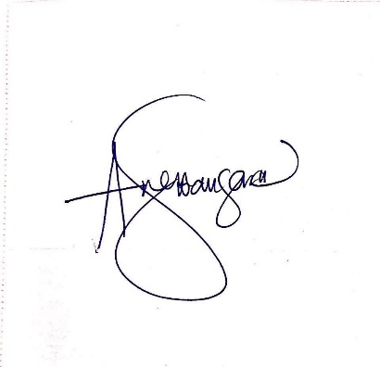*I hereby certify that the statement written above are true and correct made in good faith.*