**CIRRCULAM VITAE**

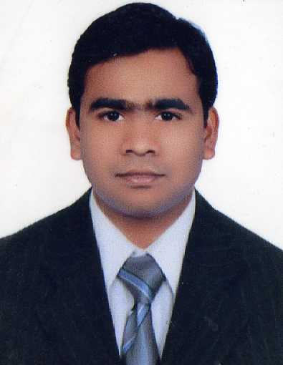

***NAME : BIJU KUMARVIJAYAN***

***CONTACT NUMBER : +973 35035969***

***: +91 8137854736***

***E-MAIL ID : biju.kumar4asha@gmail.com***

***India Kerala***

***OBJECTIVE***

**Myexperience has given me confidence to take up any challenging tasks and grow with the organization .I am adequately aggressive in pursuing my objectives. My determination combined with dedication has rewarded me in the past and I will maintain the same in the future too.**

***PERSONAL DATA***

**DATE OF BIRTH : 30-05-1989**

**PLACE OF BIRTH : Kerala**

**NATIONALITY : Indian**

**SEX : Male**

**MARITAL STATUS : Married**

**RELIGION : Hindu**

**PASSPORT NUMBER : P0075511**

***EDUCATIONAL QUALIFICATION***

**SSLC**

***AREA OF INTEREST***

* ***Purchasing***
* ***Finance***

***WORK EXPERINCE***

* ***Am A Pre-Opening Staff ( 06/2015 )At Rotana Hotel as Store Helper and promoted as store keeper( 8 / 2016 ) and am promoted again as Purchasing Buyer also i got 2 promotions and am working as Buyer now total 4 years Purchasing Experiance***
* ***I have good knowledge for the beverage and all the product***
* ***I have a good knowledge of FBM , JANA SYSTEM and FMC system***
* ***I was a waiter in Cove Rotana Resort and Got promotion as Bartender i have total 6* Years experiance in service**
* **Ras Al Kaimah hotel in ras al kaimah as a barista I worked there 3 years**
* **One year worked as bar man in Keertana International Hotel in Bangalore**
* **Worked as sales excutive in city Bank in b’lore 1and half year**

**Job Description:**

* **Doing blind test for the product to se the best quality**
* **Eild test for seafood and meat**
* **Good commnication with Chef and the suppliers for the best items to be deliver**
* **Design, plan and implement sourcing and purchasing strategies**
* **Work with suppliers, manufacturers and internal departments  
   Maintain a database of approved suppliers**
* **Build and maintain relationships with suppliers and vendors**
* **Negotiate lower pricing**
* **Search and source potential suppliers and vendors**
* **Track, measure and analyze company expenditures**
* **Provide reports for upper management**

**REFERNCE:**

1. ***Mr. Abdul Elahi***

***Corporate Director ( Rotana Hotels ) Audhabi***

[***Abdul.elahi@rotana.com***](mailto:Abdul.elahi@rotana.com)

***Wats ap number :+97433776768***

1. ***Syed Rijwan***

***Purchasing Officer ( Rotana Hotel Doha )***

***Syed.rijwan@rotana.com***

***Phone number :+97433540890***

1. ***Ganesh***

***Purchasing Officer ( Rotana Hotel Doha )***

***Phone number :+974 50220543***

1. ***Ejas***

***Purchasing Officer ( Rotana Hotel Doha )***

***Phone number :+974 55014956***

***LANGUAGE KNOWN:***

**Malayalam,Tamil,Kannada,Telugu,English and Hindi**

***DECLARATION***

**I am capable with teamwork even individual task manager. I hereby declare that the above information furnished is true to the best of my knowledge.**

**BIJUKUMAR**