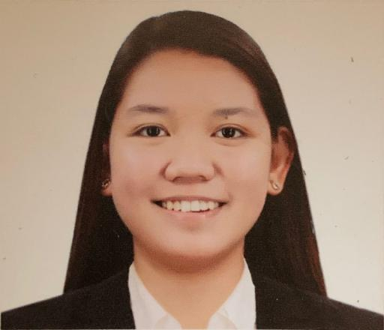**Tricia Shania F. Kyle**



**Personal Information**

House No. 671 Road 1619 Block 816 Isa Town

+97333374165

[kyletrisyaaaa30@gmail.com](mailto:Kyletrisyaaaa30@gmail.com)

Female

July 30, 2000

19 years old

 **Objective**

To acquire valuable knowledge and skills to complement those that I have learned from school and in actual job enrollment and to be able to work in an environment that promotes personal growth and uplifts professional development.

 **Education**

Tarlac State University

Bachelor of Arts in Psychology

1. 2020

Tarlac National High School

Special Program in the Arts

2011-2015

San Jose de Urquico Elementary School

2005-2011

 **Skills**

Microsoft Office Applications

Interpersonal Communication

Management/Problem Solving

Group Processing

Group Facilitation

Leadership

**Internship**

Associate Guidance Counselor

Tarlac State University

College of Science

 **Seminars**

January 21, 2019 UP NEXT: A SEMINAR ON WORK ETHICS & ANTI-SEXUAL HARASSMENT

Career & Job Placement Services & Center for Gender & Development,

Tarlac State University

November 10, 2018 CORPORATE ETIQUETTE

TSU-COESSE, The Psychological Society

Tarlac State University

May 18, 2018 2018 MENTAL HEALTH AWARENESS OF TARLAC STATE UNIVERSITY “SHARE THE JOURNEY”

TSU-COESSE, The Psychological Society

Tarlac State University

February 3, 2018 GOAL ORIENTATION AND MOTIVATIONAL TALK

TSU-COESSE, The Psychological Society

Tarlac State University

January 22, 2018 COUNSELING, TESTING, AND CAREER CENTER SEMINAR ON PERSONALITY “I AM”

TSU-Guidance and Counseling Center

Tarlac State University

January 20, 2018 THES-IS IT! RESEARCH THE EASY WAY: VALIDITY AND RELIABILITY IN INSTRUMENTATION

RGO

Holy Angel University

October 23, 2017 SPEAK UP, REACH OUT

TSU-Guidance and Counseling Center

Tarlac State University

March 27, 2017 THRIVING QUOTIENT

TSU-COESSE, The Psychological Society

Tarlac State University

November 12, 2016 POSITIVE PSYCHOLOGY

TSU-COESSE, The Psychological Society

Tarlac State University