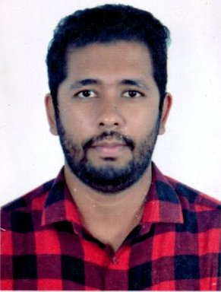

Name & Surname : **MOHAMMAD AMIR HAMZA ANIK** C P R : **881266876**  Mobile No : **00973- 35687948** E- mail  **:** [**mdamirh271@gmail.com**](mailto:mdamirh271@gmail.com)

**Manama, kingdom of Bahrain.**

|  |
| --- |
| **Subject :** |

Job Applied for : **Any Suitable Job.**

|  |
| --- |
| **Personal Information** |

Father Name : Md Shahjahan Mazumder Nationality : Bangladeshi Sex : Male Marital Status : Married Date of Birth : 06th December 1988 Place of Birth : Bangladeshi Religion : Muslim

|  |
| --- |
| **Languages** |

Arabic (Little), English, Hindi & Bengali

|  |
| --- |
| **Education Qualification** |

2006-2007 : Secondary School Certificate (S.S.C)

2008-2010 : Higher Secondary Certificate (H.S.C)

|  |
| --- |
| **Professional Experience** |

* 2 years 6 months worked as a **“Office Boy”** with **BAHRAIN TOURISM & EXHIBITIONS** **AUTHORITY** in Kingdom of Bahrain.

|  |
| --- |
| **Declaration** |

I declare that the above said details are true and correct to the best of my knowledge. To finds a challenging placement where I can contribute my experience and knowledge and to apply acquired skills achieved by means of experience and hard working.

**Your Faithfully**

**Mohammad Amir Hamza Anik**