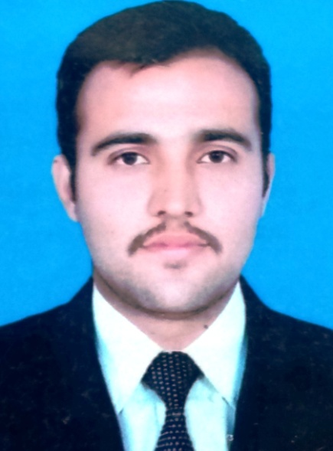

**+973-35585905 (Bahrain)**

**Shahidsky2015@gmail.com**

________________________________________

**Professional Skills**

* **Marble Polish**
* **Public Area Machines**
* **Cleaning Chemical**
* **Team Management**

**Education**

* **High School Certificate**

**Personal Information**

* **Date of Birth 02-04-1991**
* **Nationality Pakistani**
* **Passport No VY6890482**
* **Marital Status Single**

**Languages**

* **English**
* **Urdu**
* **Punjabi**

**Reference**

* **Will be provided upon request.**

**Shahid Hussain**

**Housekeeping Team Leader**

**Objective:-**

Seeking a position to utilize my knowledge and experience skill in an organization. My objective will be to carry out the responsibilities with effectiveness, efficiently and discipline. I will endeavor to be ready for challenges and remain steady to accomplish my objectives.

**Experience:-**

NOV 2017 TO MARCH 2020 │BAHRAIN│JUMEIRAH ROYAL SARAY HOTEL

**Team Leader (Rooms & Public Area)**

Handle Guest Complaint & Feedbacks in Professional Manner.

Supervise work activities of cleaning personnel to ensure clean, orderly rooms. Examine rooms, halls, and lobbies to determine need for repairs or replacement of furniture or equipment, and make recommendations to management.

Maintains working relationships and communicates with all departments.

SEP 2013 TO MARCH 2017│ QATAR │ CROWN PLAZA DOHA.

**Night Shift In Charge / Floor Polisher / Public Area**

Supervise activities of public area staff to ensure clean safe and well supplies toilets, public rooms, F&B area / outlets / janitor rooms and stores.

Check and polish all the public areas where polishing is needed.

To check all public area equipment cleans, safe and appropriately used by pub area staff.

Train all public area staff accordingly & polish the tiles at designated areas.

Supervise and monitor activities of contract cleaning companies.

JULY 2012 TO SEP 2013│ QATAR │ CROWN PLAZA DOHA.

**Room Attendant**

Clean rooms and bathroom, performing any combination of the following duties

Keep fire exits and staircase clear of any obstruction.

Check and report any maintenance required immediately.

Make bed, wash sink, bathtub, toilet, tiles, mirrors and floor and polish brass and metals.

Replenish bathroom supplies and room supplies.

**_________________________________________________________________**

**Detail Oriented Active Listener Creative Thinker**

**_________________________________________________________________**