**RESUME**

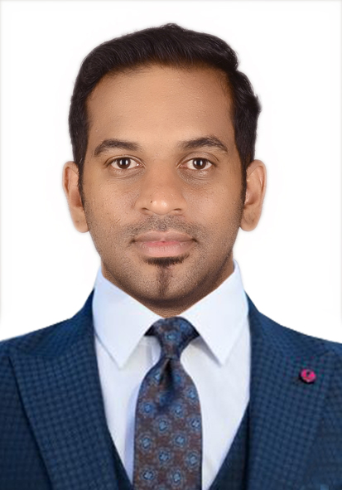

**ASHISH THOMAS**

**Mobile No.: 00973 39466823**

**E-mail :** [**ashishpalam@hotmail.co.uk**](mailto:ashishpalam@hotmail.co.uk)

**PROFESSIONAL SUMMARY:**

A competitive, well-organized and successful **Business Associate** having 10 years of experience in all aspects of the sales and marketing, customer relations, and International procurement. Having professional attitude and ability to be flexible and handle challenges in a positive manner. Holding master’s degree in business administration from **The University of Wales, UK** accumulated with excellent communication, leadership and organizational skills.

**KEY SKILLS & COMPETANCIES:**

|  |  |
| --- | --- |
| **PROFESSIONAL** | **PERSONAL** |
| * Strong in Microsoft office tools * Procurement & Planning * Client and Negotiations * Material management * Supplier Management * Marketing & Public Relations * Health & Safety management * People management * Document control * Customer service | * Able to pick up new business & technology concepts quickly * In-depth understanding of various business industries and environments * Team player * Professional appearance * Goals oriented * Strong sense of responsibility * Interest in lifelong learning |

**WORK EXPERIENCE:**

* **Multi wing group**

*Designation: Key Accounts Associate since June 2018.*

Major activities include: -

* Collecting information about latest projects and getting enquiries
* Reaching the sites to get business and Reporting back to senior manager
* Maintaining detailed knowledge of the company’s products or services
* Technical support before, due, and after selling process
* Marketing for contractors, consultants and dealers
* Coordinates sales plans with all the departments
* Achieve sales target.
* **Zybo Tracking Solutions**

*Designation: Customer Acquisition Manager from Dec 2016 to May 2018.*

Major activities include: -

* Acquiring new customers and generating sales revenue based on periodic targets
* Continuously follow up leads by visiting prospective clients regularly
* Maintain good customer relationship and offer assistance and guidance to customer
* Identify prospective client’s requirements by questioning, observation and the completion of full sales survey
* Analyze statistics to identifying key sales areas, problems and success rate
* Research on prospective client details and identify all available data about the company to  
  ensure a professional approach
* Constantly monitor and understand competitor activities to generate improved sales pitch
* Create and send business proposals to prospected clients
* **Seven Seas LTD–UK & Ireland**

*Designation: International Procurement Specialist from Jan 2013 to Sept 2016*

Major activities include: -

* Organizing and planning procurement activities.
* Ensuring product volumes, and order to achieve target sales objectives.
* Negotiating commercial contract arrangements with local & international suppliers
* Getting the best buying terms and conditions & the most competitive prices possible
* Negotiating prices, quantities and delivery time-scales with a supplier’s sales team
* Sourcing suppliers through direct contacts, conferences and networking events
* Responsible for making sure that contracts, insurance requirements and safety standards are correctly complied with company policies.
* **Shell retail UK– Leeds (England)**

*Designation: Assistant Retail Manager & finance officer from June 2011 To Jan 2013*

*Retail sales Associate (part time) from May 2010 to Jun 2011*

Major activities include: -

* Monitor and maximize sales & profit of the retail section and innovate new methods for sales maximization.
* Handle banking and maintain accurate statistical and financial records of staff and store.
* Ordering, Organizing, and arranging stock and maintain optimum inventory level based on sales targets
* Supervising staff for maintain organized store environment as per standards of Spar UK.
* Recruiting candidate for various vacant positions and providing them with adequate training
* Ensuring safeguard safety and employee rights of staff during the working hours.
* Monitor and review staff and store performance on a regular basis
* Implements new strategies for improve staff productivity and customers shopping experience.
* Delivers an excellent customer experience, helping customers choose the right product and/or service for their requirements
* Report to the Customer Service Manager and accountable for handling customer enquiries and complaints, working to provide optimal solutions and quickly resolve any issues to the satisfaction of the customer.
* **HDFC Securities - India**

*Designation: Security Sales Associate from July 2007 To Aug 2009*

Major activities include: -

* Reported to the branch manager and responsible for preparing daily workloads for staff &  
  co-ordinating the daily allocation of work
* Motivate the team to achieve high standards and KPI targets on a regular basis
* Handled new client enquiries and acted as the first point of contact within the business and customer
* Promptly deal with all customer complaints and problems, which arose in line with company policy.
* Provide motivation and feedback to team members resulting in the creation of a positive working environment.

**ACADEMICS:**

|  |  |  |
| --- | --- | --- |
| **Qualification** | **University** | **Year** |
| Master of Business Administration (MBA) in  Finance and Retail Management | University of Wales, United Kingdom | 2010 - 11 |
| Bachelor’s in Business Management (BBM) | Bangalore University, India | 2004 - 07 |
| Pre-University certificate in commerce | Kerala State Board, India | 2002 - 04 |

**COMPUTER PROFICIENCY:**

* Microsoft Office Packages (Word, Excel, Power Point, Access, Outlook)
* Window, Mac, Linux & various office tools
* Inventory Management tools

**LANGUAGES KNOWN:**

|  |  |  |  |
| --- | --- | --- | --- |
| * English | * Hindi | * Malayalam | * Tamil |

**PERSONAL DETAILS:**

Date of Birth : 06th August 1987

Nationality : Indian

Marital Status : Married

Passport No. : S8982141

CPR NO : 870875957

Driving License : Bahrain

Address : Flat 21, Entrance 15, Road 2901, Manama, Al Salmaniya 0329, Bahrain.

**REMARKS:**

|  |  |  |
| --- | --- | --- |
| * Available for Relocation | * Ready to join immediately | * Reference on Request |

**DECLARATION:**

I, Ashish Thomas, hereby declare that all the above, mentioned details are true to the best of knowledge and belief.

**ASHISH THOMAS**

Mobile # 00973 39466823