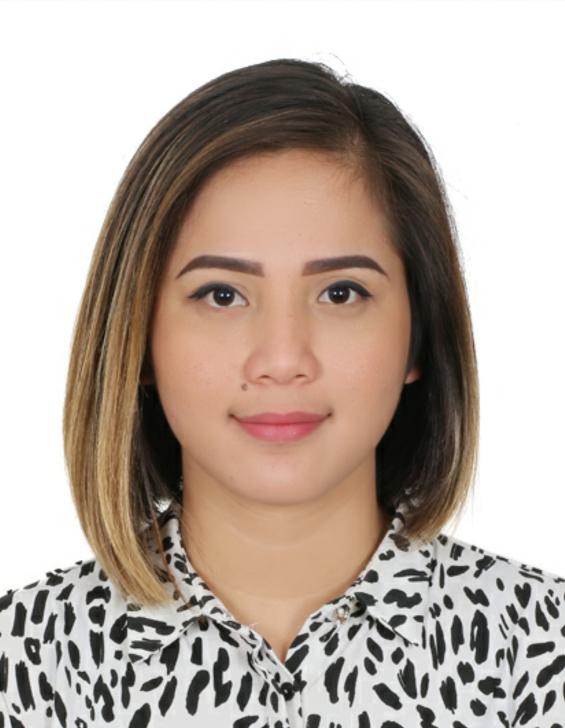 |  | EDUCATION
CABARRUS CATHOLIC COLLEGE
Computer Secretarial (undergraduate)
2006-2008

GMNHS BRGY.V EXTENSION
(Graduate)
2001-2005

TIGBAO ELEMENTARY SCHOOL
(Graduate)
1995-2001
chenne visitasion entes  Profile  A well-presented, articulate and confident individual with a proven ability to provide exceptional customer service with a total of 4 years in extensive experience in hospitality industry. Having an outgoing personality, good interpersonal skills and ability to work in a multi-national team environment with confidence and comfortable working in a fast paced environment and able to build and maintain good relationships with work colleagues.  CONTACT  PHONE:  +973-33183560  EMAIL:  Haiezha201@gmail.com |  | WORK EXPERIENCE
MEISEI RESTAURANT - Adliya Manama, Bahrain
CAPTAIN WAITRESS
May 2017 – March 2020
Being a Team Captain is more challenging than a normal waitress. Following the company rules is must done first from me then to the member. Managing the complaints and concerns from the staff and to the guests. In terms of the food and services need to be knowledgeable and well-trained with the perfect and professional way of service.

THE SHOGUN LOUNGE – Beirut, Lebanon
WAITRESS
January 2015 –May 2017
My position as a waitress in Shogun Lounge really helped me to work under pressure. My duties is to take orders from the guests as they arrived in the dining table after they seated. I would then relay the orders to the kitchen and bring the prepared meals to the guests in the very short space of time, whilst simultaneously ensuring that mess was tied up and tables sanitized before the next diners seated themselves at the tables.

TOY KINGDOM – SM CITY BACOLOD PHILIPPINES
SALES CLERK
December 2012 –September 2013
My position as Sales clerk in Toy kingdom was helped me to communicate people. Selling a toys product is easy for the babies but for the parents is really hard. We have to convince them about the quality and the usage of the product.

SIPALAY SUITES – SIPALAY CITY, PHILIPPINES
RECEPTIONIST
March 2010 – September 2010

 |  | SKILLS AND ABILITY
- Good communication skills

- Good interpersonal skills

- Able to work under pressure

- Capable to work in long time

- Good in analytical skills

- Ability to provide excellent customer service

- Computer literate

- Ability to manage multiple projects independently

- Capable for problem solving
- Able to quickly learn and key in to new position

- Hardworking, Honest, and Loyal

PERSONAL DETAILS

Birth Place : Calatrava, Philippines
Birth Date : June 20, 1989
Age : 30 years old CHARACTER REFERRENCE
Height : 5’4”
Weight : 55kg. Samer Soukhon
Nationality : Filipino Operation manager Shogun Lounge, Beirut Lebanon
Language : Tagalog (excellent) +961-709-93090
English (fair)
Dexter Cardornigara
Coordinator
Richprime Global Inc., Toy Kingdom
SM City Bacolod Branch, Philippines
+639-1023-99709

Lenielyn Mateo
Former Supervisor/ Purchaser
Jamont Grocery, Sipalay City Philippines
+639-4655-22830

Jaymar Nortate
Supervisor
Meisei Restaurant
+973-3401-7558

