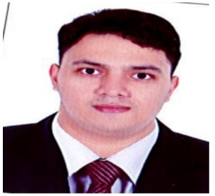Joshua peter mendiola vidamo

**Flat 44 Bldg 26A Palace Avenue**

**Area 306 Manama, Bahrain**

**Mobile #: 33112243Email: joshuapeter005@gmail.com**

# Objective

To be an efficient team member and to be ready for the task given and to enhance my skills and learn new techniques.

# Experience

Wazzupdod Juffair,Bahrain

Waiter/Cashier

March 12, 2019-March 12,2020

Ramada Manila

Line Cook – was assigned to run the buffet and the ala carte section of the restaurant and to prepare foods from soup to dessert

Nov 2017 – Jan 2018

B Hotel QC

Baker – was assigned to make and bake cake for the hotels pastry store and to make different kinds of bread

July 2017 – Sept 2017

# Education

**LPU CULINARY INSTITUTE**

Diploma in Professional Culinary Arts

**LYCEUM OF THE PHILIPPINES UNIVERSITY-MANILA**

Bachelor of Science in Culinary Arts and Kitchen Operation (Undergrad)

**Secondary Education**

St. Mary’s College of Meycauayan

**Primary Education**

Mary Child Academy – Gr. 3-6

Paco Catholic School- Grade 1-2

# PERSONAL INFORMATION

* Age – 23
* Birthdate – June 13, 1997
* Place of Birth – Malate, Manila
* Nationality – Filipino
* Status – Single
* CPR #: 970627033
* Passport #: P7064734A