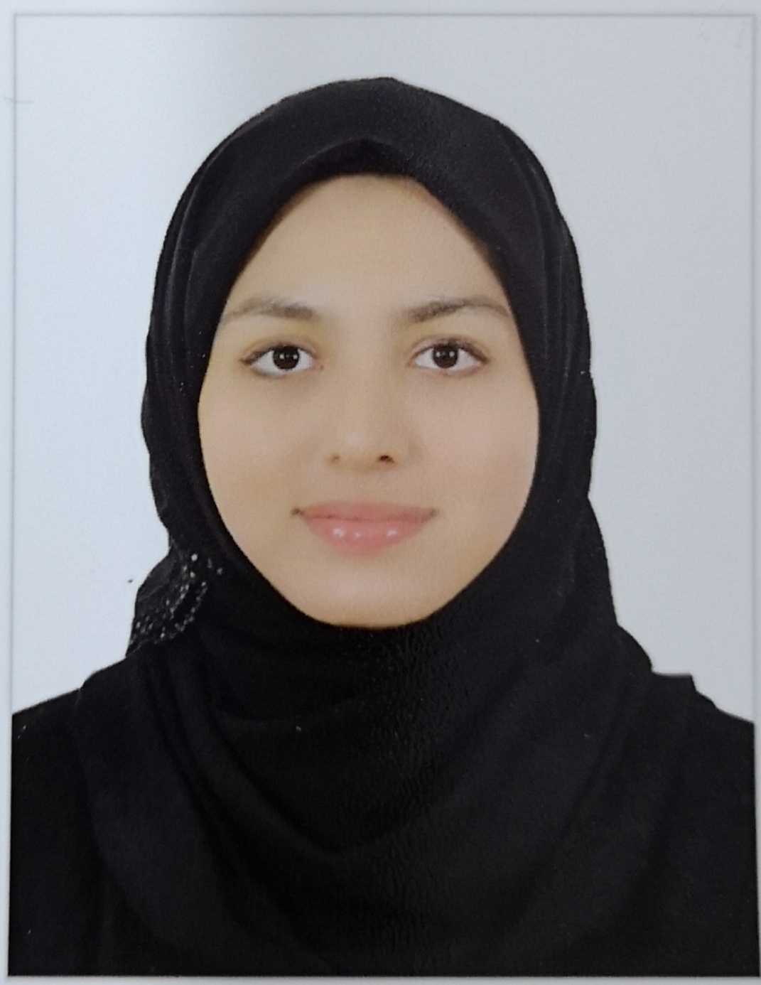 |  |  |  | ZUNAIRA  MALIK

Experience
July 1, 2019–October 10, 2019
Trainee • Accounting Department • Four Seasons Hotel – Bahrain Bay
Tasks
- Accounts Payable:
Checking the Goods Receiving Reports, posting invoices in the Back-office system, Preparing Payments in Back office system, Preparing Bank transfers.

- Accounts Receivable:
Preparation of Invoices for Clients and amendments, following up for payments, reconciling customer accounts, Posting payment in Opera, Processing of rebates and refunds.

- Income Audit:
Checking the allowances and rebates, Checking the Paid outs by Front Office, Checking the House Settles, Credit Card Reconciliation

- Systems Learnt:
Sun System, Opera PMS, Micros

Education
B.Sc. in Business Management, University of Bahrain, February 2020
- Major : Management
- Minor : Finance
- GPA : 3.27

HSSC in Commerce, Pakistan Urdu School Bahrain, February 2020
- Subjects : Principles of Accounting, Principles of Economics, Commercial Geography, Principles of Commerce, Banking, Business Mathematics, Business Statistics
- Grade : A

Personal Profile
Date of Birth: 22 September 1997
CPR: 970912307
Holder of Car Driving License - Bahrain

Skills
- Good leadership and management skills.
- Fast learner
- Hardworking
- Strong ability to prioritize activities and meet deadlines.
- Self-Motivation
- MS Word
- MS EXCEL
- Presentation Skills

Languages
Fluent in Urdu/Hindi and English.

Hobbies
- Acting/Drama
- Basketball
- Reading
- Volunteer work

References
Available upon request

 |  | Flat 22, Building 3383  Road 2661, Area 226  Busaiteen, Bahrain
 |  | +973 3940 4988
 |  | zunairamalick22@gmail. Com
 |  | 970912307

