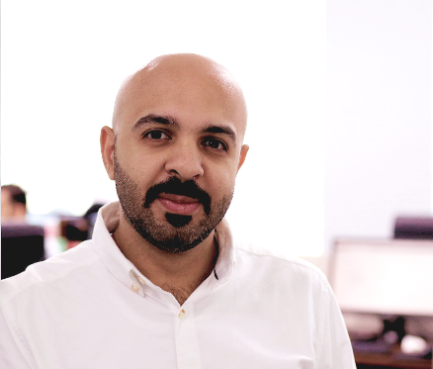 MOHAMED ALSAROO

Familiar with MS Word, Excel, PowerPoint and Internet applications; able to learn new programs. Skilled at utilizing CRM and data management tools to optimize sales, marketing, and customer loyalty. Skilled in research, analyzing data, writing, editing, planning, communicating and coordinating.

# EMPLOYMENT

**2018 - Present** PLATFORM SPECIALEST– **DIGISPHERE SOLUTIONS**

* Managing all content created on our platform (homiez.me & hardhats.me) and make sure that following the guidelines of the platform.
* Collaborate with marketing and design teams to plan and develop site content, style, and layout.
* Liaise with writers of content to ensure consistency of the brand.
* Optimize the SEO content.
* Analyze website traffic and user engagement metrics using content management systems.
* Collaborate with the IT development team to make sure all found bugs been cleared.

**2016 - 2018** Project cOordinator– **GROOVY EVENTS**

* Managing the social media accounts for two major Events: Dubai Schools & Childcare show – Bahrain Family Expo on Facebook, Twitter and Instagram (@Scsdubai & @bahrainfamily).
* Keeping in close contact with key Project members and decision-makers.
* Preparing quotations, invoices, and receipts for all exhibitors.
* Track and report project progress.
* Follow up with our vendors to keep them updated about Project requirements.
* Updating the project’s website on a daily basis with the new exhibitors and new news about the project.
* Set the marketing plan for our projects.

**2016 - 2016** Retail Administration Executive– **BATELCO**

* Identify, Analyze and audit all retail shops report required by Management.
* Enhance the Retail system processed by identifying gaps and areas to be developed.
* Audit, monitor and report the daily/ Weekly/ Monthly sales Achievement.
* Audit, monitor and report the daily/ Weekly/ Monthly Management/ Staff performance and efficiency through EDW, CCTV, VMS, etc.
* Analyze Reports for all promotions and KPI’s.
* Evaluate and check any new promotions or packages and make sure it’s as per the agreed process.
* Investigate, follow up and decide on complex complaint/court cases.

**2007 - 2016** Sales Executive– **BATELCO**

* On daily basis, process customers’ service orders related to Fixed line, Mobile, Internet (ADSL, etc., and ensure that all customers’ requests have been provided in a timely and accurate manner by clearing suspended and rejected service orders quickly.
* Accept payment of all services provided & ensure that it gets accounted for in the company records. Prepare and tally daily financial transactions made and safely deposit all revenue collections ready for Banking.
* Deal with all customers’ accounts enquiries & transactions such as partial payments, dispute amounts, ROS/TOS, installments, the refund of the deposit, refund or transfer, etc.
* Provide/promote all products & services provided by the Company to meet the department sales targets. Be in a professional position to answer customers’ enquiries about products & services.
* Liaise with other sections to ensure that customers’ requests and orders are processed in a timely and efficient manner to meet customers’ maximum satisfaction.
* Process all types of Company Phone cards, Prepaid Cards to both agents and individuals.
* Provide responsible Controllers with relevant information related to daily operational activity statistics.
* Deal directly with, follow-up and resolve customer complaints, and direct customers’ feedback to Product Managers and different customer segments managers.

# EDUCATION

**2003 – 2006** ASSOCIATE DIPLOMA -mARKETING– **University of Bahrain**

# Course

**April 2014** ADVANCED SALES MANAGEMENT– **HORIZON HRD**

**January 2010** CUSTOMER DELIGHT– **HORIZON HRD**

**November 2009** SELLING TECHNIQUES– **HORIZON HRD**

# RefERENCES

mr. Abdulqader madan- area manager- batelco

39440770

mr.Habib Almarzooq- ceo & founder- groovy events

38888996