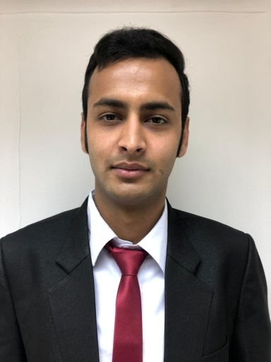

**Bibek Sanjel**

Al Hoora, Bldg.196, Road #1906, Blk. 319

Email: bibekfpl@gmail.com

Mobile No. : (+973) 35642712

**Personal Profile**

Seeking for a job in hospitality industry preferably in the kitchen. I have the ability to work under pressure and. I am eager to learn, I enjoy overcoming challenges, and I have a genuine interest in Kitchen Industry.

**Education**

2019 –Present **Diploma in International Hotel and Tourism Management**

**Operations**

Hospitality and Tourism Management Institute(HTMi)

Barbar, Kingdom of Bahrain

August 2013 - **Diploma in Secondary Level**

January 2016 Bani Bilash Higher Secondary School

**Experience**

2014- 2015 **Hillside Resort, Nepal**

Nepal, Bhaktapur

Kitchen Staff

* Cooked soups, sauces, main dishes and desserts from a variety of cuisine styles
* Prepared vegetables, fruits and meats as ingredients for dishes and platters
* Took inventory of supplies and completed order forms

2015 -2016 **Himalayan Herbal, Nepal**

Nepal, Kathmandu

Marketing Salesman

* Guiding the buyers
* Attending to complaints

2018-2019 **LCWAIKIKI, Seef mall**

Manama, Bahrain

Marketing salesman

* Collection of credit information
* Reporting, organizing stocks
* Arranging for packing and delivery
* Promotion of goodwill

2019- 2019 **Bahrain Airport, Arrival 2**

Manama, Bahrain

Barista

* Prepares or serve hot and cold beverage
* Cleans or sanitize work areas, utensils, or equipment
* Checks temperature of freezers, refrigerators, or heating equipment to ensure proper functioning

2020 – Present **Papa John’s**

Juffair, Bahrain

Kitchen Crew

* Covered duties inside the kitchen and service area
* Cleans or sanitize work areas, utensils, or equipment

**Trainings and Workshops attended**

September 22 — **Korean Cuisine Training**

26th 2019 with Celebrity Chef ‘Jang Hee Young’

At Bahrain Institute Hospitality Retail

**Extra-Curricular Activities**

April 24 — **YPO**

28, 2019 Young President Organization

At Ritz Carlton, Manama, Bahrain

Oct 31st — **Cultural Festival Day**

2019 at Bahrain Institute Hospitality Retail

Jan 26th – **Italian Master Chef Season 6**

2020 at Cucina Italian, Juffair, Bahrain

**Language**

* Nepali Native Language (Read, Write and Speak)
* Hindi Secondary Language (Read, Write and Speak)
* English Secondary Language (Read, Write and Speak)

**Interests and Hobbies**

* I like travelling, I travelled in all famous spots in Nepal, Swayambhunath Kathmandu Durbar Square, Chitwan National Park and Pokhara

**Personal Information**

Nationality Nepalese

Gender Male

Marital Status Single

Date of Birth 15th OCT 1998

Passport No 10729803

**References**

Ms. Daisy Jovenes

Faculty

BIHR (Bahrain Institute of Hospitality and Retail)

E-mail: daisyjovene@yahoo.com

Ms. Imelda Milan

Faculty

BIHR (Bahrain Institute of Hospitality and Retail)

E-mail: melmilan.milan1@gmail.com

BIHR (Bahrain Institute of Hospitality and Retail)

Telephone #. +973 3430 2760