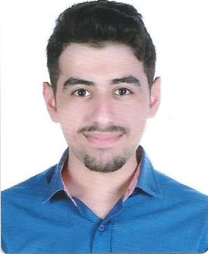**Hussain A.Ali Al-Salman**

Address: Building 759, Road 3516, Block435

Jeblat Habshi-Kingdom of Bahrain

E-mail: haaalsalman@hotmail.com

Mobile: 35514050

# PERSONAL DETAILS

CPR: 980707307

Date of Birth: 22th July 1998

Marital Status: Single

Nationality: Bahraini

Gender: Male

# EDUCATION

Secondary Technical Certificate, Al Jabriya Secondary Technical ٍSchool, GPA: 91, (2013-2016).

Sector: Computer Maintenance.

MTA: Windows Operating System Fundamentals Certificate.

# Experience

Creating websites training in AppsHouse (1 Year)

Working in BIM Department Stores (3 Months)

Worked as a Cashier in Hi-Mart Supermarket (4 Months)

Work in Lily Bloom Chocolate and Flower Shop (2 Months)

# PROFILE

* Cooperative.
* Team worker.
* Enthusiastic and Fast learner.
* Ambitious.

# SKILLS

* Computer skills: typing both Arabic and English/Using Microsoft Office.
* Communication skills.
* Driving license
* Flexibility.

# SPOKEN LANGUAGES

* Arabic (Native).
* English (Good).

# INTERESTS & HOBBIES

* Computer Enthusiast.
* Playing Basketball.

# REFERENCES

Available upon request