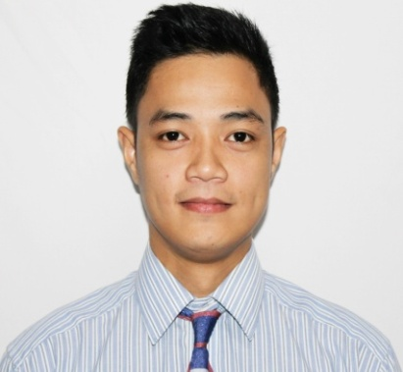**ABRAHAM D. COPE JR.**

Flat 12, Building 1663, Road 626, block 306, Ras Rumman, Bahrain

Email: [copebim@gmail.com](mailto:copebim@gmail.com)

Mobile #: 34405897

**Personal Statement:** Able to work efficiently in a team environment. Proven ability to work peacefully and efficiently under pressure.Capable of reading and understanding basic cooking procedures. Highly motivated, determined and reliable. Strive to achieve the goal. Has passion for excellence. Like learning, being busy and enjoy communicating, assisting and interacting with other people.

**Career Objective:** To obtain a new and challenging position that will enable me to gain new skills. To develop more my communication skill, to grow and to learn more.

**PERSONAL DATA**

Birth date: July 12, 1991

Birth place: Camalig, Albay, Philippines

Age: 28 years old

Height: 5’8/ 176cm

Weight: 71Kg

Status: Single

Religion: Roman Catholic

**EDUCATION**

**Hotel and Restaurant Services- 2010-2012**

*Christ the King Science and Technology* – Putatan, Muntinlupa City, Philippines

*\*Graduated as Most Outstanding Student* in Diploma in Hotel and Restaurant Services

**Hotel and Restaurant Management- 2008-2009**

*University of Perpetual Help*– Las Piñas City, Philippines

**Skills gained**

* Outstanding customer service skills.
* Ability to establish a harmonious relationship with colleagues despite different nationalities.
* Ability to establish a pleasant and efficient team.
* More developed intra and interpersonal skills.
* Leadership skills.
* Operations assistance qualifications.
* Flexibility and time management.

**WORK EXPERIENCE**

***THE GRUB SHACK GRILL-*** 1st floor, Seef Mall Seef, Bahrain

**SUPERVISOR-** Feb 2019- Oct 2019

Key Responsibilities

* Assisting restaurant manager in maintaining stocks and inventory of all product items.
* Ensure customer satisfaction through excellent customer service.
* Check restaurant on daily basis to ensure cleanliness, high quality food and excellent service.
* Responsible on making weekly staff schedule.
* Assisting and coaching new employees.
* Timely communication of inventory and cash handling.
* Attend to customer needs; responds to customer complaints tactfully and professionally.

***COUSINS BANQUET RESTAURANT -*** Bldg 36A Block 326 Hassan Bin Thabit Ave, Adliya, Bahrain

**ASSISTANT COOK-** Aug 2017- Feb 2019

Key Responsibilities

* Inspect food preparation and serving areas to ensure observance of safe, sanitary food handling practices.
* Ensure proper procedures were followed when working with cooking equipment.
* Observe and test foods to determine if they have been cooked sufficiently, using method such as tasting, smelling, piercing them with utensils.
* Substitute for or assist other cooks during emergencies or rush periods.
* Regular checking of supplies before during and after work.

***PAN CAKE HOUSE*** – Molito Commercial Complex, Madrigal Ave, Alabang, Muntinlupa, Philippines

**KITCHEN CREW-** January 2015 – January 2017

***GALLI VILLAGE CAFÉ*** – YMCA Hotel, Sacred Heart St., San Antonio Village, Makati City, Philippines

**WAITER**- January 2013- January 2015

**TRAINING/AFFILIATION**

**INTERCRUISES HRMC**

February 06-10, 2017- *Integrated Skills Preparations and Familiarizations for* **Food and Beverage/** **Housekeeping**/**Bartending** /**Front Office Service Operations**

4th floor Astoria Building A. Mabini St, Ermita, Manila

**Marketing Team Member- 2010-2012**

*Christ the King College of Science and Technology*– Putatan, Muntinlupa City, Philippines

* Answer queries and assisting enrollments.
* Entertain and tour visitors around the campus.
* Helps marketing team to go to different schools to promote school.
* Communicating with students and helps in school activities.
* Attends to guest/students concerns.
* Perform other duties as assigned.

**CHARACTER REFERENCES**

Upon Request.

I hereby certify that the above information are true and correct to the best of knowledge.

**ABRAHAM D. COPE JR.**

**Applicant**