**RESUME**

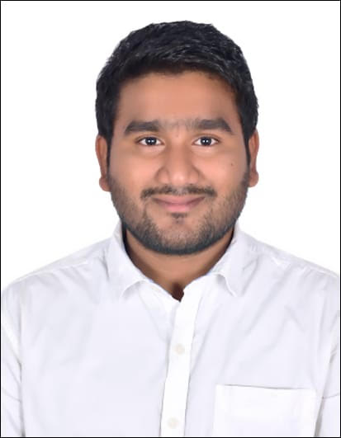

Name: **Sai Prasad Nathari**

Email: saiprasadnathari94@gmail.com. Phone: +973-35311064

## **CAREER OBJECTIVE**

To play a decisive role in diverse areas of development leading to the organization’s growth, touching higher realms of professional excellence with productive use of my knowledge, creative mettle and intellectual prowess.

## **EDUCATIONAL QUALIFICATIONS**

* **Bachelor of pharmacy** from Gurunanak institutes of technical campus with 66% passed in 2017.
* **Intermediate** from Sri Chaitanya Junior college with 75% passed in 2012.
* **S.S.C** from Gowtham model high school with 83% passed in 2010.

## **PROFFESIONAL SUMMARY**

* Currently working as **Branch Supervisor** for UAE Exchange WLL, Bahrain since 2 year.
* 4 Years of experience as Sales and Marketing.

JOB RESPOSIBILITIES

* Review prescriptions to ensure prescription of correct doses.
* Generates information and suggestions on the use and effects of medications.
* Issues prescribed medicines and packages in accordance with strict control procedures.
* Dispenses medications according to the inpatient physicians' orders and outpatient physician's prescriptions.

## **STRENGTHS**

* Excellent interpersonal and communication skills.
* Knowledge in various computer applications, languages and operating systems
* Ability to multitask
* Flexibility to learn advancements in the industry

## **TECHNICAL SKILLS**

* **Online entries for analysis using quality control management software**
* **EZ-CHROME**
* **AUTO CAD**
* **Microsoft office Package-Excel, word, Outlook etc.,**
* **Operating System –Windows (10, 98, XP, 7) & Mac OS**
* **Software-4M Fine HVAC software.**

## **PERSONAL DETAILS**

**Date of birth :** 18/11/1994

**Gender :** Male

**Passport Number :**  R1587096

**Marital Status** : Single

**Languages Familiar** : English, Hindi, Telugu

**Nationality**  : Indian

## **DECLARATION**

I hereby declare that all the information written above is true to the best of my knowledge.

Date: 16-03-2020

Place: Kingdom of Bahrain (*Signature*)

Sai Prasad Nathari