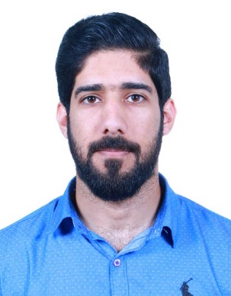**Curriculum Vitae**

**Sulman yar Mohammad**

**Contact : 33265535, 36055833**

**Email:** [**salmanyar89@gmail.com**](mailto:salmanyar89@gmail.com)

**Building#20, Block#3401, Road#334, AL Mahuz Manama, Kingdom of Bahrain.**

***Personal details:***

Date of Birth : 18-09-1989

C.P.R. No : 890906564

Nationality : Bahraini

Marital Status : Single

Religion : Islam

***Objective:***

A recent business economics graduate honors degree from University of Bahrain, looking to secure a graduate job or like utilize my current business skills and knowledge and help me to further develop these skills in a practical and fast-paced environment.

To work in a Business field and contribute positively and honestly, apply what have been studied and achieve self-actualization through being gentle and devotee to the clients, seniors and staffs.

***Educational Qualification:***

**2011-2017** B. SC. Banking and Finance, University of Bahrain.

**2009-2010** Secondary and intermediate – Pakistan Urdu School Bahrain,

Federal Board of Intermediate and Secondary Education,

Islamabad Pakistan.

***Internship:***

Internship in Perla Campo Consultancy.

***WORK EXPERIENCE:***

**2015-2017** Perla Campo Consultancy as an Assistant Accountant.

Bahrain International Circuit as an Organizer.

**2010** AL Muntaza super Market as a Cashier.



* Injaz: Company program (entrepreneurship).
* Attended a Business symposium.
* Worked as an Organizer At business symposium.
* Attended ICT Innovation and Entrepreneurship symposium.

***Additional Skills:***

Languages Known : English, Arabic, Baluchi and Urdu.

Interpersonal Skills : Team working, analytical and communication skills.

Computer skills Certificate of Microsoft office specialist in MS Windows

Program like MS Office (Word, Excel, PowerPoint,

Access).

***INTERESTS AND HOBBIES:***

Interested in (Book reading about the general of business).

I have a keen interest in photography. I was a photographer in Bahrain cricket association during 2016.

I also play Cricket.

***REFERENCES:***

References are available on request.