**VIJAYA ELUMARTHI**

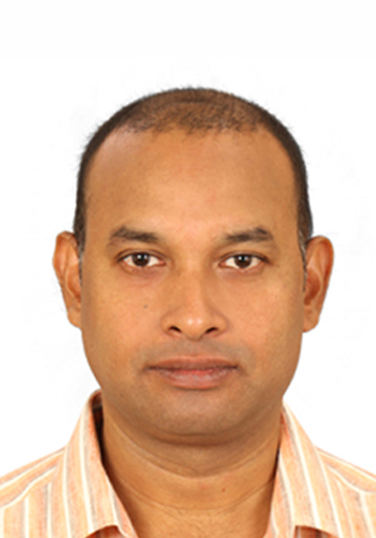

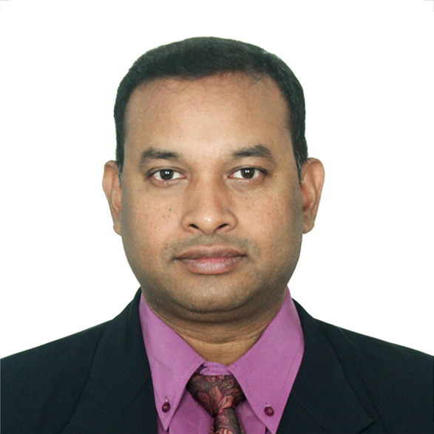

**Flat 2 BLDG 239 RD 2508, Near ENMA Mall Riffa/Bu Kuwarah Blk 0925 Bahrain.**

Receiver**+973 35621963 +918340806024 SKYPE: Vijay Elumarthi**

****[**evvpratap@gmail.com**](mailto:evvpratap@gmail.com)**,** [**evvpratap@yahoo.com**](mailto:evvpratap@yahoo.com)

**OBJECTIVE**

Looking for a position in Contracts administration, Mechanical engineering, Maintenance, Material/warehouse/Inventory and quality (ISO) management; preferably with leading Oil & Gas majors that offer both a challenge and a good opportunity for growth.

**PROFILE SUMMARY**

An **astute** Proficient Contracts Administrator with 10 years automotive industry experience. Proven record of contract management and settlements upwards $20M. Excellent communicator and leader with strong interpersonal skills.

Well versed with international standards such as **ISO 9001, 14001, ANSI, ASME, API, NACE, AISI, SAE, DN** and so on. Excelled in the fields of ADMINISTRATION, QUALITY, CLIENT MANAGEMENT and well-equipped to take on an role.

**CORE QUALIFICATIONS**

|  |  |
| --- | --- |
| * Bid preparation * Negotiations * Lifecycle Documentation * Cost Analysis | * Contract management * Platform Integration * Contract Settlement * Interpersonal skills |

**OCCUPATIONAL CONTOUR**

**Contracts admin for NSH WLL, Bahrain July’19 till Nov’19**

* Conducting migration from current document management and contract management system to WorkSite (aka iManage Work) system
* Provide guidance and assistance to contract providers and assist with contractor training
* Work with Project Managers to assist with scope development
* Provide calendar management for the Senior Contract Manager and Senior Subcontractor and Commercial Manager
* Develop working knowledge of project specification (General and Technical terms) and assist Project Manager with specification compliance
* Establish contract management plans, measure and monitor commercial/technical performance and provide regular reporting
* Assisting Contract Managers/Support Team Manager with contract reports

**Contract and Commercial, Iridium SDN BHD, Brunei Darussalam Jun ’18 till Apr’19**

* Communicate with vendors, labor specialists, material suppliers, and company executives to procure equipment and employees to meet project requirements.
* Create sourcing strategies and contract proposals to procure necessary resources quickly while meeting budgetary and quality standards.
* Participate in contract negotiations to pursue company goals and ensure effective communication between labor directors, suppliers, and internal managers.
* Develop and implement new arbitration procedure for contract disputes that increased resolution rate by 30 percent while reducing arbitration time by 10 percent.

**Asset and Commercial Manager, Flux O S Sdn Bhd Brunei Darussalam Nov’17 till May ’18**

* Generated required contracts and liaise with third parties.
* Researched and investigated solutions to meet client contractual requirements.
* Prepared all contracts Confidential Disclosure Agreements (CDA’s) and amendments within time constraints.

**SCM & Assets management at KCADeutag Drilling Company, Brunei Jun’12 till Nov’17**

* Represented company’s interests during contract negotiations with suppliers, including formulating policies and creating counter-proposals.
* Directed purchasing activities of procurement team, including drafting resource requirements, purchasing equipment and materials, and distributing resources to correct departments.
* Created and maintained comprehensive list of materials and suppliers to increase efficiency of resource procurement and minimize purchasing timeline.
* Developed strategic sourcing workflow to reduce duplicated efforts in procurement department and improve overall efficiency.

**SCM specialist, Serial Drilling Company (UK) Brunei Jun’09 till Jun’12**

**SCM Coordinator, IRAN KCADeutag Drilling Company, Iran, Dubai Jul’01 till Dec’02**

**Warehouse coordinator, Oman Deutag Drilling Company, Kuwait, Muscat Aug’98 till Apr’01**

**Assistant Driller Oman Drilling Company, Muscat, Yeman Apr’98 till Aug’98**

**Roustabout Mentor, Oman Deutag Drilling Company, Muscat Sept’97 till Jul’98**

**ACADEMIC CREDENTIALS**

* MBA-with specialization in project and Maintenance management-2018
* Bachelor of Technology, Mechanical-2009
* Diploma in Mechanical Engineering-2006
* Diploma in Materials Management-2001
* PG Diploma in Computer Applications-1997
* Industrial Mechanical Training (ITI)-1994
* Secondary School Certification-1989

**KNOWLEDGE ENHANCEMENT SCHEDULES**

* Certified Contract Manager-University of Southampton, UK(ccm)
* Onshore and offshore rig inspection training - IADC
* NS-1 & 2 quality and inspection training - Fearnley Procter Group
* Supervising for Safety Training (SFS) – SHELL Brunei
* Worksite Hazard Management (WHM) – SHELL Brunei
* Lead auditor course, KCA Deutag Drilling Ltd; UK
* Safe to Lead course; Amsterdam; Norway
* Strategic Warehouse Operations, UNI Strategic Pte. Ltd; Kuala Lumpur
* Competent inspection supervisor for bottom hole assembly at SHELL training centre, Brunei
* Defensive driving skills at Megamas training centre Brunei
* Competent Worksite Supervisor Training during at Megamas Training Centre, Brunei
* SAP training; Ditechnologies; Aberdeen, UK.

*PERSONAL DETAILS*

Date of Birth : 01st June 1975

Permanent Address : Plot No-E50, House No-5-4-205, Road No-4, street No.5 Kamala Nagar

Vanasthalipuram, Hyderabad- 500070, Telangana, India.

Languages Known : English, Hindi, Telugu, Tamil

Passport no. : Z4205558 (Expiry date: 05th Jan 2027) Indian

CPR/Driving License : 750676833(Bahrain)

REFERENCES – Available on request