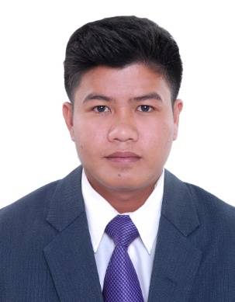

**Manuel T. Rayo II**

**Mobile: +97337789419**

**E-mail:**[eralou019@gmail.com](mailto:eralou019@gmail.com)

**Address**: **Flat 11 Bldg 122 Rd 320 Al Zahraa Ave Blk 307**

**PROFILE**

A challenging determinednewlygraduate with good communication skill and ready to work both independently and as a member of a team,utilizing the skills and knowledge acquired during my education and experience intend to build a career with leading corporate & dedicated people, which will help me to explore myself fully and realize my potential. I’m willing to work as a key player in challenging & creative environment.

* A young versatile and hardworking professional seeking a career in any industry
* Possessesstrong communication skills gained through customer focused roles.
* Ability to perform effectively under pressure and adhere to set timescales.
* Displaying a positive and ambitious attitude determined to succeed and has the confidence to integrate quickly into new settings and become a valuable member of the team.

**WORK EXPERIENCE**

**PTRGeneral Merchandise,** Nov 2015 to March 10, 2016

**Sales Assistant/Cashier**

**Duties**

* Setting-up merchandise for sales
* Administers sales transactions with customers.
* Assisting customer merchandise selection
* Inventory management of all merchandise
* Administration and other duties as directed.

**Emperor Flower Shop November 2016 (Until Now)**

* Florist
* Cashier
* Sales Man
* Merchandiser

**Duties**

* Processing payment
* Greeting customers
* Decorate’s Flower
* Wrapping a Gift
* Arranging Stuff
* IG; emperor_flower

**CORE COMPETENCIES**

* Dynamic & Hardworking `
* Exceptional team-building skills
* Effective organizational skills
* Eagerness to Explore and Learn
* Excellent Interpersonal relationship and communication skills
* Maintaining excellent Customer Relations
* Attention to details
* Quick decision-making abilities
* Ability to withstand criticism and irritated people

**EDUCATION QUALIFICATIONS:**

* **College:**

MMA (Multimedia Arts)

STI COLLEGE Las Pinas April 5, 2015 (Graduate)

Metro Manila, Philippines

* **Secondary Education:**

Bacoor National High School

Bacoor Cavite Philippines 2007-2011

**PERSONAL DETAILS**

**Date of Birth :** 12thJune 1993

**Gender :** Male

**Marital Status :** Single

**Nationality :** Filipino

**Passport No :** EC5042187

**Languages Known :** English, Pilipino, Visaya

**COMPUTER SKILLS:**

* ***Operating System****: Windows OS,*
* ***Software’s Known*** *: MS Office Suite (Excel, Word, Powerpoint, Outlook), Adobe Photoshop, Adobe PageMaker, Adobe Premiere, Adobe Illustrator, Adobe Flash, 3d Blender*

**References available upon request**