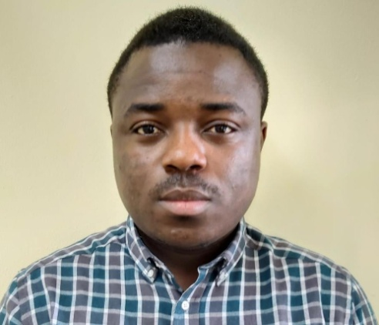 ***Name:* MBONDA MARCEL EKOLE**

Nationality: Cameroon

Cell : 33001055

Marital status: Single

DOB : 04 February 1993.

Email : [Mbondamarcel@gmail.com](mailto:Mbondamarcel@gmail.com)

***Career Summary:***

I’m an energetic, committed and fully qualified teacher with an experience of five years who has a passion for teaching science (Physics) a track record of excellence. During my career I have gained vast experience of developing a student's knowledge, skills, and attitude. I possess the ability, skills and determination to make a real and significant difference to the lives of students across different grade levels and from different backgrounds. As a superb communicator, I`m more than able to establish a classroom atmosphere in which students are held accountable for their own behavior. Right now I`m looking for a suitable teaching position with an oversubscribed and popular institute where, passionate, bright and ambitious teachers can make a significant impact.

***AREAS OF EXPERTISE TEACHING***

* Having comprehensive knowledge of a teacher’s professional duties and legal responsibilities.
* Ability to read, analyze and interpret directives from educational bodies.
* Developing lessons and activities that encourage students to become involved in a class.
* Expertise in using technology to enhance teaching and learning.
* Able to work in stressful situations and when under pressure.
* Looking after the welfare of students, specifically signs of abuse or neglect.
* Experience of working in a team environment.
* Able to act on own initiative in identifying and resolving academic and teaching shortcomings.

***PERSONAL Summary.***

* Ability to prioritize so that deadlines are always met.
* Willing to plan an active role in developing an ever-changing curriculum.
* Can communicate and build rapport on all levels.
* Treating all students fairly, consistently and without prejudice.
* Enjoy working with children and young people.
* Possessing an enthusiastic teaching style that keeps students engaged.

***CAREER HISTORY***

***Middle East SCHOOL BAHRIAN***

Physics Teacher (Grade 7, 8 and 9) 2017– Present

* Undertaking any supervisory duties as required by the Principal. Administer tests, analyze the data, place the student in proper program
* Notify parents of results and placement and make sure they have access to all information
* Provide accommodations and make sure they are being met
* Discuss results with other teachers and explain how to accommodate student’s academic weaknesses.
* Collaborate with mainstream teacher about lesson plans, cultural sensitivity, and diverse resources.
* Assist in creating classroom assessments or make necessary modifications
* Create meaningful lessons that will benefit the child’s individual needs.
* Prepare interesting semester projects for students and do proper follow up so all students complete the task.
* Prepare break activities so as to give the students a fun environment during break periods.
* Member of the health and safety department in school, so as to help make sure we are in a safe environment

***BRITISH ISLES INTERNATIONAL SCHOOL DOUALA Cameroon***

Physics Teacher (Form 3, 4 and 5) 2014–2016

Responsible for maintaining good order and discipline amongst students, and for teaching them according to their educational needs and academic ability.

***Duties:***

* Creating classroom activities and assignment that are appropriate to a students learning ability.
* Initiate, nurture and moderate classroom discussions.
* Advising students on any career issues, and discussing what they intend to do after they leave school.
* Maintaining accurate daily attendance records.
* Promptly responding to inquiries from the parents of any student.
* Communicating and consulting with the parents of students.
* Safeguarding the health and safety of students whilst they are in the classroom
* Participating in school extracurricular clubs and societies.
* Assisting trainee and junior teachers in their fulfilling their duties.
* Addressing all teaching problems and student shortcomings promptly and effectively.
* Marking and monitoring every students' work and setting targets for future progress

***ACADEMIC QUALIFICATIONS***

Bachelors of curriculum studies and teaching in Physics University of Buea Cameroon 2013.

*Hobbies:*

Football, Movies, Swimming.

***REFERENCE***– Upon request.