**ALLEN DEPOT LUBANGAS**

Manama, Bahrain

Phone Number: +973 3518-6476

E-mail Address: [adlubangas@gmail.com](mailto:adlubangas@gmail.com)

To whom it may concern:

I am writing this letter to your good office for I am interested to the position your company is offering. As a highly competent Hospitality Service Provider, I am very willing to work with you for long term with the right attitude, being efficient and an effective employee.

In my current position, I always make sure that my guests and our restaurant operations is well attended and satisfied not only in the entrée’s they are ordering but as well as my service. I try to work well independently that I will not fail in providing and going beyond our company’s standards. I am very eager as well to work with my fellow employees to be more competent in the Hospitality Industry.

I was a self- starter and absorb in the company I once worked before, Forest House Bistro and Café awarded as *“One of the Philippines Best Restaurant for 10 years up to this date* by the Asia Tatler. I was able to excel at serving my guests with accuracy, efficiency and effectiveness, with a friendly attitude as well as overseeing fellow team members enforcing company’s protocols and standards.

I have also worked as Waiter/Batista and Juice Maker in Le Chocolat Café and Restaurant, my first company overseas.

I am currently working as a Head Waiter/Assistant Supervisor for Hanali Food and Beverages.

I am hoping to be part of your team for a new career opportunity and career growth to be more competent in my field of expertises.

My Curriculum Vitae and references are attached. Please take a chance on reviewing my information that I have provided and feel free to contact me any time.

Sincerely,

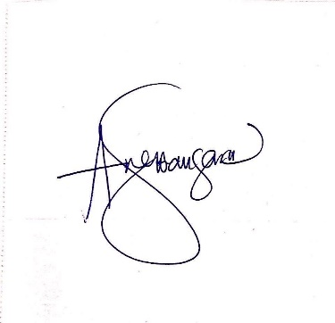

Allen D. Lubangas