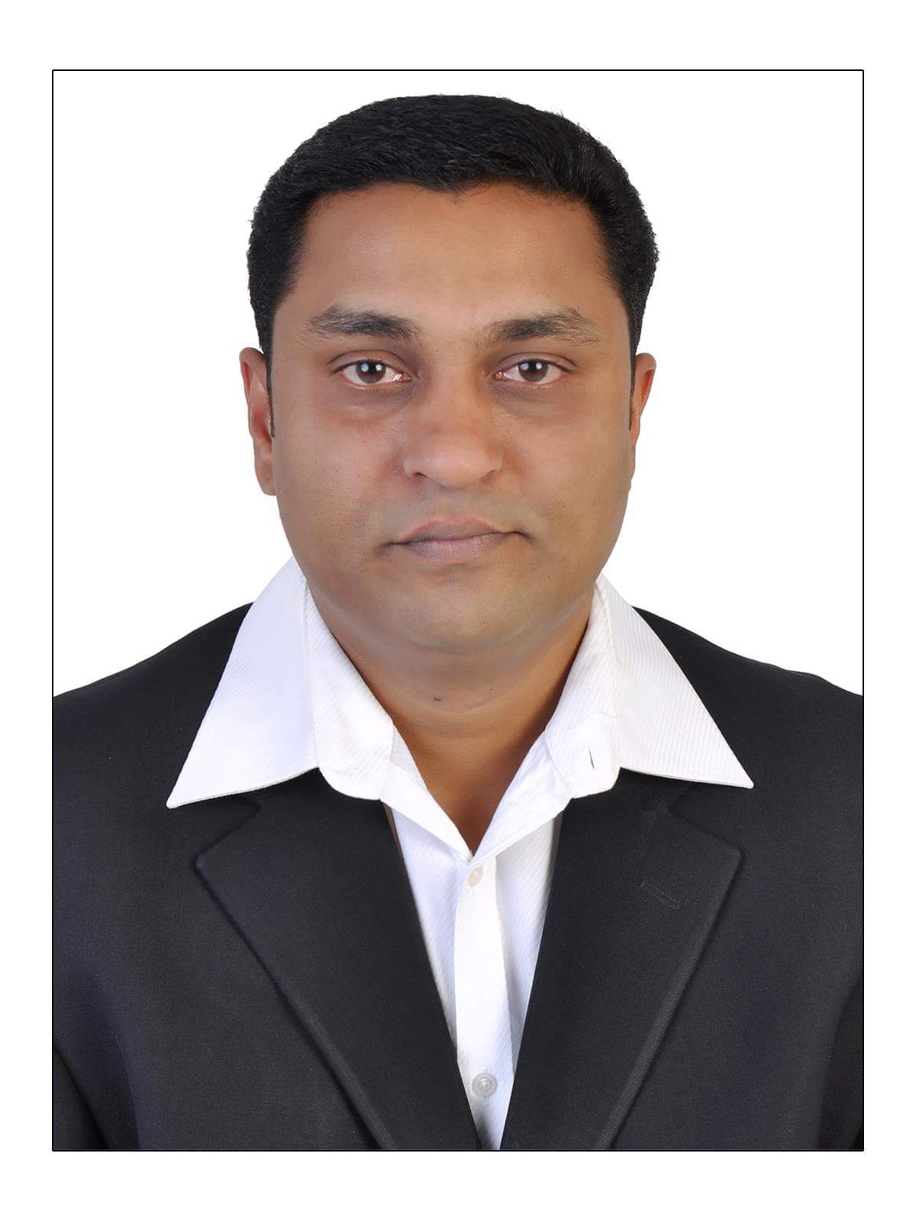

To be part of an organization where gained technical and management knowledge can be applied in an innovative and competitive way and to help the organization to achieve its goals in an effective manner

**Mob: +973 34016035, 37772334**

**Email: [bobbyandria8@gmail.com](mailto:bobbyandria8@gmail.com) /bobby_koshy@hotmail.com**

**Bobby. K. Koshy**

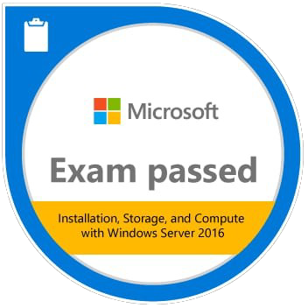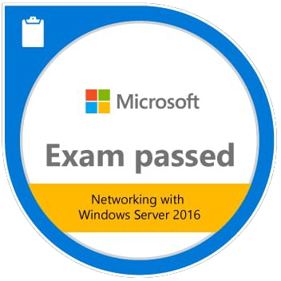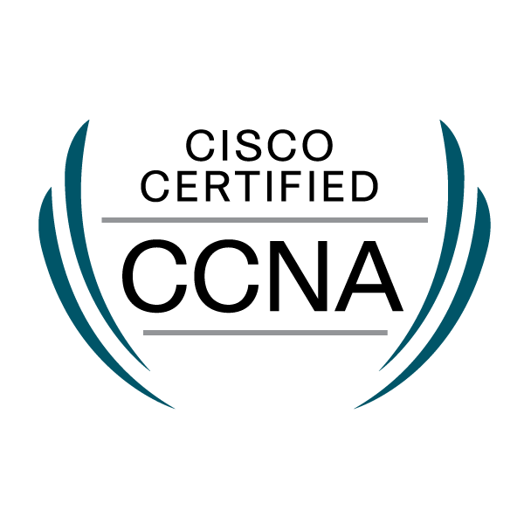

Skills

* Good knowledge in computer System Administrator & networking
* Efficient team player with excellent interpersonal skill
* Possessing natural leadership quality
* Good communication skill

Work Experience

* **November 2015 – November 2020**

**IT Executive**

Retail Global Fashion W.L.L (Red Tag & Twenty 4)

* **July 2009 – November 201**5

Al Rashid Group (Division of Land Mark Group) Bahrain System Service Engineer & Network Support.

* **April 2003 – June 2009**

Smart Tech, Cochin, Kerala, India

System Engineer & Network Support

* **August 2001 – March 2003**

Computer Solution, Coimbatore, Tamil Nadu, India

System Engineer & Network Support

* **September 2000 – May 2001**

CCIT, Kollam, Kerala, India

Hardware Engineer as Well Software Trainer

Education

* Microsoft Certified Azure solutions Architect Expert (MCID 990906635)
* CCNA (Routing & Switching )
* MCP (Microsoft Certified Professional) KARROX Palakkad (Windows 2000 Track).
* MCSA (Microsoft Certified System Administrator) ACCEL Cochin (Windows 2003 Track).
* ITIL Foundation Certificate in IT Service Management (GR750114176BK)
* Kerala Board of Public Examination Govt. High School, Kozhippara.
* 12th Grade Department of Government Examination Madras.
* PGDCA (Post Graduate Diploma in Computer Application) VABS Palakkad.
* Diploma in Computer System Maintenance (Computer Hardware) CEDIT Kollam.

Computer / IT Knowledge

* Installation, configuration and administration of Windows 2016 & 2019 server and professional.
* Installation and configuration of Windows desktop operating system.
* Installation and configuration of Linux operating system.
* Implementing and administrating Windows 2016 &2019 network infrastructure.
* Installation, configuration and servicing of all hardware’s.
* Computer assembling and troubleshooting.
* Deploy & Maintain Microsoft Active Directory Domains.
* Implementation & Maintenance of structured LANs Having D-LINK Switches.
* Installation and Maintenance of devices like Printers, Scanners, Thumb Scanners & Touch Screen.
* Installation & Troubleshooting of LANs and WANs.
* Installation & Administration of Microsoft Active Directory Domains.
* Sophos and Fortygate Firewall.
* Installation, Configuration & Servicing of Point of sale Systems.
* Configuring Cisco switch from factory default using console connection such as hostname, login and interface.
* Familiarization and configuring RAID adapter to provide increased performance and increased reliability of multiple disks.
* Have good knowledge on networking and Cisco Basic Switching
* Antivirus Sophos, spam filtering Sophos Antivirus, Quarantine manager, Spam and AV filtering
* VPN configuration (IPSEC, site to site SSL VPN)
* Configuring Endpoint.
* Switching and routing (CCNA)

Personal Details

|  |  |  |  |  |
| --- | --- | --- | --- | --- |
| Name |  |  | : | Bobby Koshy |
| Fathers Name |  |  | : | K.M Koshy |
| DOB |  |  | : | 25th of May 1981 |
| Sex |  |  | : | Male |
| Marital Status |  |  | : | Married |
| Passport Number |  |  | : | F2431777 |
| Nationality |  |  | : | Indian |
| Driving License |  |  | : | Valid Bahrain license |
| Contact Address |  |  | : | Bldg No. 640 |
|  |  |  |  | Galali |
|  |  |  |  | Manama |
| Contact No. |  |  | : | +973 34016035, 37772334 |
| Email Address |  |  | : | **bobbyandria8@gmail.com** **bobby_koshy@hotmail.com** |
| Languages Known |  |  | : | English, Hindi, Malayalam and Tamil |
| Hobbies |  |  | : | Listening music, reading, playing cricket. |

Reference will be provided on request