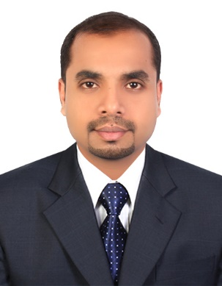 | Rajeesh Rajan  Email: rajeeshrajan75@gmail.com  Mobile : 0091 7736833224

Summary: A motivated, friendly and enthusiastic individual with excellent communication and customer service skills with 6+ years’ work experience in Airline and travel agencies in India, UAE & Bahrain.

Objective: Seeking a suitable position in an Airline / Travel agency and to contribute in the organization growth.

Profile Summary

- 6+ year’s working knowledge in Airline/ Travel Management companies.
- Sound knowledge in Airline GSA affairs.
- Good rapport with various dept. like Reservations, Ticketing, Pricing & sales support.
- A good team player with excellent communication skills.
- Excellent working knowledge of various GDS like Galileo, Amadeus.

Career Summary

Senior Customer Service Agent
Fly Dubai May 2016 to June 2020
Manama, Kingdom of Bahrain

- Managing Reservation & Ticketing and UAE Visa processing.
- Preparing daily sales report & flown segments report.
- Successfully handling “ holidays by flydubai” ( Holidays department)
- Coordinating with Trade partners and liaising with HO for group departures.
- Analyze and Submitting fare comparison report to Sales Manager.
- Providing after office hrs support to trade partners and Airport team.

Travel Consultant Apr 2014 to Apr 2016
Jazan Travel & Tourism Agency
Sharjah, United Arab Emirates

- Issuing BSP tickets and Low cost Airlines tickets and Travel Insurance.
- Successfully handled the travel requirements of SME’s and Corporates.
- Coordinate with Airlines for seat confirmation and special service requests.
- Preparation of Daily sales report and submit to the sales manager.
- Handling Retail counter and managing cash transactions.

Travel Consultant Feb 2013 to Mar 2014
Akbar Travels of India Private Limited
Akbar Group, Pattambi Branch, India

- Issuing BSP tickets and Low cost Airlines tickets to the clients
- Successfully handled the Retail travel desk
- Successfully handled ticketing requests of the Sub Agents.
- Coordinating with regional office distributing special offers.
- Preparation of Daily sales report and submit to the Supervisor.
- Assisting Visa section & Passport requests.

Customer Support Executive Jun 2010 – Jan 2013
HDFC Bank, Trissur, Kerala

- Install swiping machine in hotels, shops, shopping malls
- Responding to customer inquiries, troubleshooting and resolving issue
- Follow-up both by telephone and email and ensuring the service quality

Education

- Bachelor of Arts :History & Economics ; Calicut University, India

- Diploma in Travel & Tourism :Emirates college for Management studies, Ottapalam, Kerala, India; 2013

Computer proficiency

- GDS: Amadeus, Galileo and Abacus.
- Tally.
- Diploma in Computer Application and M S Office.

Personal Details

- Nationality : Indian
- Date of Birth: 12th March 1988
- Languages Known: English, Hindi and Malayalam
- Holds valid Bahrain Driving license & Indian Driving license

References

- Available upon request

