**CURRICULAM VITAE**

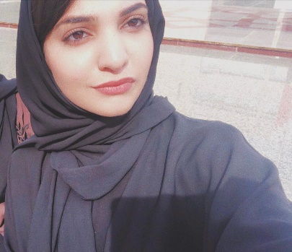

**Name:** Zainab Afzal Khan

**C.P.R No:** 990702979

**Nationality:** Bahraini

**Date of Birth:** 10 July 1999

**Language:**

* **English** ( writing, reading and verbal )
* **Arabic** ( Basic Knowledge )
* **Urdu** ( reading and verbal )

**Email:** [zainabafzal37@gmail.com](mailto:zainabafzal37@gmail.com)

**Marital Status:** Single

**CAREER OBJECTIVES:**

Seeking the position that suits my qualifications and experiences also develop my skills and abilities.To reach the new levels of excellence where my creative initiative ideas and a genuine enthusiasm would allow me to progress and satisfaction in my job and ability.

**EDUCATIONAL QUALIFICATIONS:**

**2018-2019:** Currently a student at Bahrain Polytechnic and pursuing a Bachelor’s degree in visual designing.

**2017-2018:** Pakistan Urdu School and College, Higher secondary school certificate. ( HSSC )

**2015-2016:** Pakistan Urdu School and College, Secondary school certificate. ( SSC )

**PERSONAL PROFILE:** I am currently a student at Bahrain Polytechnic. I am an energetic and enthusiastic person who enjoys challenges and achieving personal goals. Along with that I am also a motivated and responsible individual with excellent team work and communication skills.

**INTERESTS:**

* Basketball
* Art
* Designing

**ADDITIONAL SKILLS:**

1. **COMPUTER SKILLS:**

* MS Office ( word, powerpoint, excel)
* Web surfing

1. **INTERPERSONAL SKILLS:**

* Creative thinking
* Ability to work under pressure
* Motivating
* Helping and problem solving