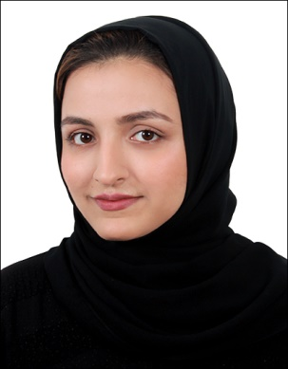 |  | Iqra Mohammad
Profile  I am a fresh graduate who is passionate to continue my career. I am a punctual and hardworking individual who is dedicated towards the tasks assigned. I am exploring a good opportunity to proof myself as one.    Contact  PHONE:  +973-33556920    EMAIL:  Iqraamalik.im@gmail.com  Hobbies    Interested in local and global news    Learning any new skill, technique, language etc.    Photography    Reading books   Cooking  LANGUAGES    English and Urdu (spoken and written) |  | EDUCATION  My education assisted me to gain confidence in myself and equipped me with new experiences. It has helped me to be able to perform in a multi-cultural and diverse environment.  Currently doing Montessori Teacher’s Training  2020  Bachelor’s in Business Administration from the University of Bahrain  2015 - 2019  High School graduate from Pakistan Urdu School, Isa town  2012 – 2014  Professional experience  Served as Teaching Assistant at Al Rawabi Private School, KG Department  24 October 2019 – 30 June 2020  - Discuss assigned tasks and plans with the classroom teacher,  - Recordkeeping of students in record book,  - Prepare bulletin board displays and demonstrations,  - Tutor students in circle time for review of lesson plan,  - Supervise students and assist them,  - Distribution and collection of homework files, workbooks, money etc.,  - Communicating with the parents via phone calls or in personal,  - Grade activity worksheets,  - Coming up with new ideas for students Montessori activities,  - Preparing hand-made activities to engage students,  - Laminate teaching materials, etc.  Worked as a trainee in University of Bahrain, Purchasing Dept.  1 July 2019 – 31 August 2019 (2 months)  - Scanning and faxing of LPO’s,  - Filing the documents,  - Data Entry,  - Interact with suppliers,  - Making calls to suppliers and completing miscellaneous required tasks.  Volunteered for a community service project in collaboration with Bahrain Trust Organization  – March 2019 - May 2019  - Set up a booth at the exhibition in University for the Strategic Management course. (MGT434)  - Supported Bahrain Trust Organization’s program of helping children in need by spreading awareness in the exhibition, about their program and their e-shop products.  SKILLS  - Quick learner  - Teamwork and collaboration  - Positive attitude and high patience level  - Decent communication skills  - Problem solving  - Ability to work in a multi-cultural environment.  Software skills  - Ms. Word  - PowerPoint  - Smart Board Knowledge.  - Basic computer knowledge.

REFERENCES

- Ms. Asma Rasool (English Co-Ordinator and my classroom teacher, KG Department) at Al Rawabi Private School.
Email: asmarasool14@gmail.com
Contact number: +973 36073545

- Ms. Fakhia Saeed (co-assistant teacher) at Al Rawabi Private School.
Contact number: +973 33120482

