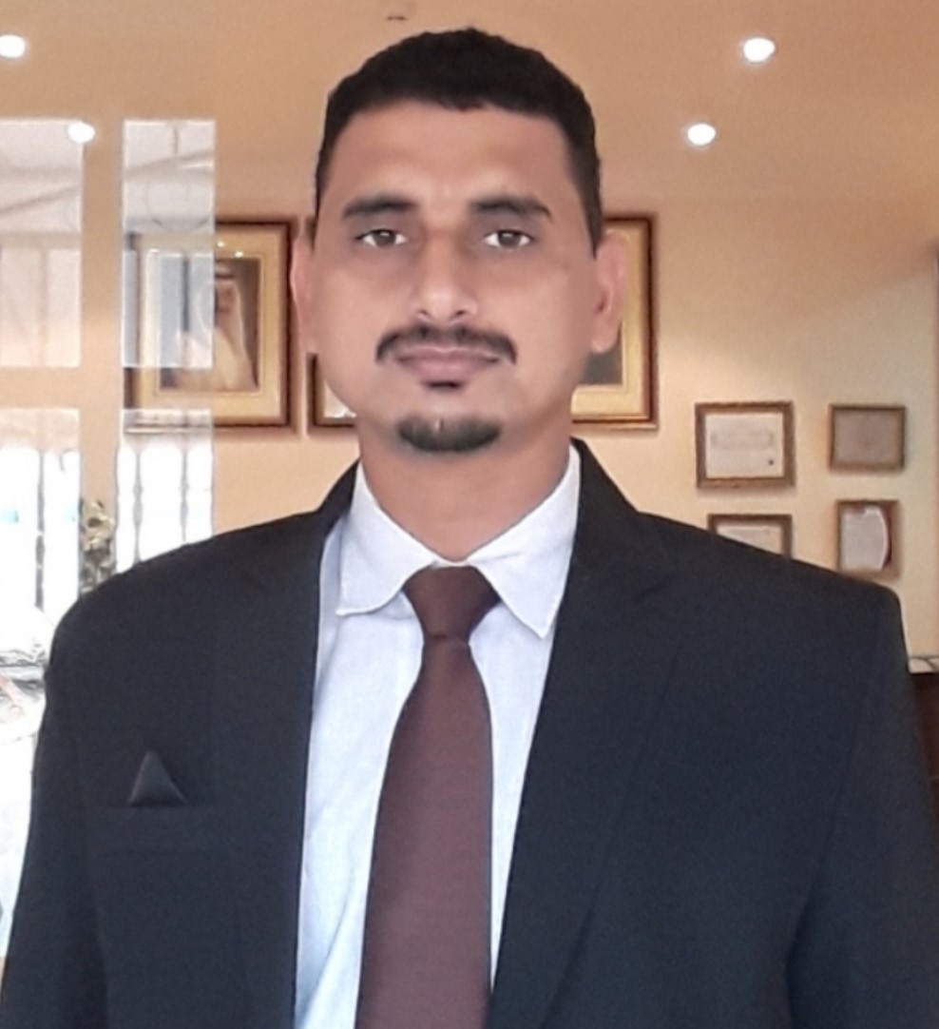

**Jai Narayan Saini**

**Focus on: Personal Assistant / Executive Assistant/ Office Manager**

Graduation- BA (English Literature)-2006 | Msc. (Computer Science)-2012

🕿 +973 3838 4277 | WhatsApp+91 98995 16961 | [jainarayan78@yahoo.com](mailto:jainarayan78@yahoo.com)

­ ­[www.linkedin.com/in/jai-narayan-saini-1ab42132](http://www.linkedin.com/in/jai-narayan-saini-1ab42132), Manama, Kingdom of Bahrain

## CAREER OBJECTIVE

Detail-oriented and highly organized personal assistant well-versed in providing seamless support to C-level executives, as well as independently performing administrative, appointments and travel scheduling, shopping, and event planning responsibilities with effortless efficiency seeks a Personal Assistant or Office Manager position with a top firm where flawless executive support services are valued.

## CORE QUALIFICATIONS

* With 12+ years of experience of Personal/ Executive Assistant to Managing Director & step below,
* Multiple Calendar & Diary, Agenda & Minutes of meeting, Good Written & Spoken skills,
* Time management & Prioritization, Empathetic skills & Focus on details, Fast accurate working,
* Complete Travel Arrangement: Air, Road, Sea, Rail & Chartered Plane Services,
* Greetings Guests & Visitors, Arranging Meetings & Business events, Hotel Accommodations,
* Expert in MS Office & Social media, Office Budgeting, Vendor & Special Project Management,
* Market Research & Data Analysis as per different kind requirements of the top Executives,
* Online Research & Data Analysis, Confidential Documents & File, Speed Keying (60 WPM),
* Maintaining Interior and Equipment’s of the Director’s offices to the standards,
* Office Operations and Policy Formulation, excellent customer service and marketing relations.

## PROFESSIONAL EXPERIENCE (Since 03rd March 2008 – Present)

**Tylos Plastic Industries CO. W.L.L.** Manama,Kingdom of Bahrain.

Secretary to ED cum Supervisor (Transport), Since: August 2016 - Present

Provide comprehensive administrative and personal support to the Executive Director & Chairman of the PVC Pipes & Fittings manufacturing company, with scope of responsibility that includes dictation, correspondence, office management, guests & vendor relations, complete travel arrangements, processing attendance of all employees for Payroll, and Accounts & Finance control of Transport (Trailer & Drivers).

* Secured time and energy of the Top management and the senior team by providing an excellent secretarial and administrative assistance while their daily routine business execution,
* Writing letters, dictation, minutes, prioritizing E-mail & Incoming documents for approval,
* Providing complete travel support to C-level Executives including all the employees,
* Handling reception/ attending guests & clients and responding marketing & sales queries,
* Renovate office operations by devising and producing necessary policies for cost effective operation,
* Sourced and secured cost-effective travel and entertainment vendor reducing travel expenses by 40%,
* Checking and processing daily attendance of the employees for monthly payroll to HR,
* Updating system (Ad-hoc software) regards to daily production of Pipes & Raw material in Stores,
* Supervising and Controlling accounts & finance for Transport division(Trailers & Drivers),

**Au Small Finance Bank**, (Known as Au Financiers (India) Limited), Jaipur (Rajasthan), India

Personal Assistant cum Assistant Manager at MD Office, February – August 2016 (6 Months)

Played a pivotal role in the fast-moving banking environment, providing assistance to company Founder- Chairman & Managing Director, even other top leaders. Responded immediately to shifting priorities/deadlines while expertly handling all aspect of complex global travel arrangements (Visa, Air/Road transport and Hotel etc.), managing multiple calendars/diaries, and resolving scheduling conflicts. Served as point of contact for MD, ED, COO, CFO, VP and step below when they are traveling, arranged all needs for large-scale meetings across the globe, and ensured accommodation of last-minute changes.

* Resolved numerous scheduling conflicts to ensure success of high-priority Internationally-based meetings/events for MD & ED,
* Achieved savings for costly requested supplies i.e. (Travel, Meetings, and Office) by personally contacting sources to secure a lower price,
* Interact with customers approaching to Managing Director, when appropriate and problem solve, document complaints and develop an appropriate course of action to increase loyalty or satisfaction,
* Played a role of Personal Assistant to MD saving his time and stress by carrying out several coursework representing him,
* Minimized a number of tasks/responsibilities at the MD Office by organizing procedures to save money & manpower; many of them automated.

**Sprinkles group of Companies,** Dubai-UAE

Executive Assistant to MD & CEO, January 2015 – December 2015 (1 Year)

Deliver firsthand support to senior leaders and decision makers while managing a variety of key functions including oversight/auditing of attendance system (adding/training new employees and tracking system use), review of monthly invoices, income-expenses and costs, inventory control and stock issuance. HR: Payroll, Hiring and Exit formalities, Sales: meeting with customers for complaint resolutions and sales increase and miscellaneous responsibilities handled under instructions of the MD/CEO.

* Worked as a middle point to the senior management assisting them under many responsibilities like Secretarial, Administration, HR, Finance, Inventory & Stock, Sales and public relations etc.,
* Renovated and vastly improved attendance management by researching, selecting, and driving implementation of Iron attendance system, which enables self-management by employees while ensuring adherence to policies and individual time-off allotments,
* Played a key role in communicating with customers to resolve their complaints and raised sales up,
* Contributed to cost-saving effort by working with HR department to research alternative travel agencies. Prepared a detailed spreadsheet that identified savings from each company.

**InterGlobe Aviation Limited. (IndiGo Airlines),** Gurgaon, State – Haryana, India

Administrative Assistant to Top Management Team, March 2008 –September 2014 (6.6 Yrs.)

Administrative assistant to the Heads of Cabin crew department having their dependability for various responsibility like maintaining calendar, meetings, database, cabin crew personal files, crew requests for transfer, leave and flight, TDY etc., updating ROCADE(Airline operation suite), flight schedule, various bills processing, Travel arrangement, crew hiring and attrition reporting, preparing training and internal audit plan, minutes of meeting and dictation, sorting emails, calls and writing communications etc.

* Utilized multi-tasking and time management skills to manage all the demanded responsibilities by the senior managers and made their professional life smooth and forward-looking,
* Advanced expertise in MS Excel made many complex calculations easy like cabin crew payroll and leave management system(PL, SL, ML etc.) and created an In-house application called CLMS(Crew Leave Management System) with co-ordination of IT and HR professionals,
* Independently handled a big Database and many kind of data files on papers and electronically,
* Maintained more than 3 thousand cabin crew personal files and other documents that are very confidential and sensitive in nature like AEP, Passport, MED and Police Verification for international operations,
* Excellent skill in arranging travel and transportation to make the trip comfortable and hassle free,
* Responsible to update the ROCADE – (Airline Operation Suite) accordingly for monthly scheduling purpose and interact with the Base managers for all matters related to the Crew for international flying.

## PERSONAL DETAILS

Date of Birth : 14-August-1985

Languages known : English, Hindi

Belongs To : District-Sikar, State-Rajasthan, India

Current Visa Status : Valid Employment Visa- Kingdom of Bahrain