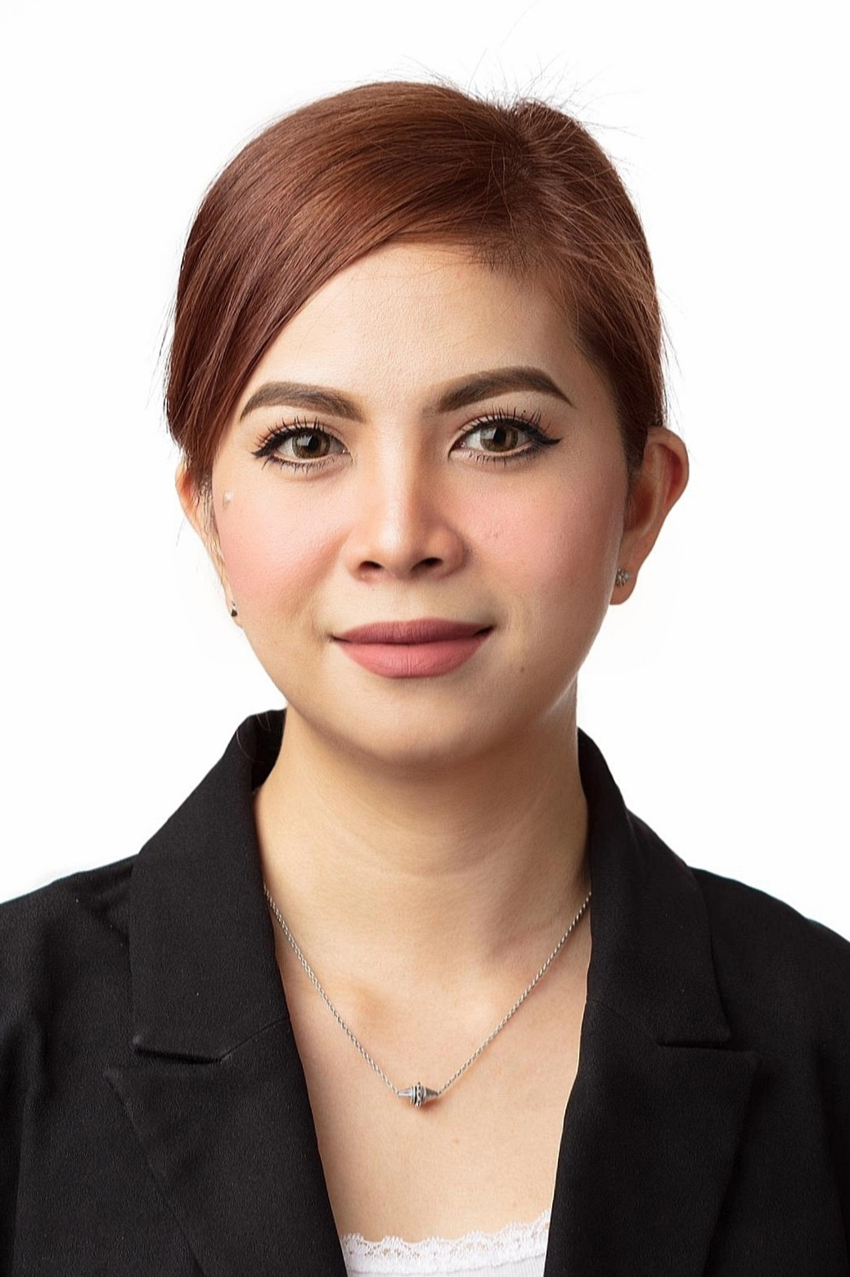**Lovely M. Laordin**

Contact no.: +973 36522779

Bldg.3431 Road 1859 ,Block 318, Al Hoora, Bahrain

Email: [lovely.laordin@yahoo.com](mailto:lovely.laordin@yahoo.com)

**PERSONAL DETAILS.**

Nationality: Filipino

Passport no. EC3116059

Driver's License: 870642499

Date of Birth :June 8,1987

Marital status: Single

Languages skills: English

Height: 5’2

Weight: 110lbs.

**CAREER OBJECTIVE**

Seeking for a position in a challenging company as a Beauty Advisor where I can provide a good contribution to generate client satisfaction

**SUMMARY OF QUALIFICATIONS.**

Knowledgeable in all aspect of cosmetology.

Experience in cosmetic and skincare.

Experience in Retail sales and customer service.

Demonstrated interest in beauty products and skincare.

Ability to interact and communicate effectively.

**AREA OF EXPERTISE.**

**Company:** Alzain Jewellery

**Period**: August 5 to present

**Position**: Sales Executive

Job Description:

* Greets and meets customers on arrival at the shop
* Listens attentively to a customer’s needs and gives explicit explanation to satisfy such a customer
* Presents the customer with the needed jewelry and provides information, such as pricing; and gives a discount if need be
* Entertains customers and answers questions respectfully
* Introduces sales promotion to customers so as to entice them to make purchases
* Ensures that products are well arranged in orderly manner
* Helps customers to make the right decisions so they can make the right jewelry purchases
* Ensures that all pieces of jewelry are returned to their secured places after the day’s business
* Ensures the proper display of company signage in order for customers to easily locate the jewelry shop or kiosk.

**Company:** Ashraf BGDC / Chalhoub Group

**Period**: March 1 2015 to July 31 2020

**Position**: Beauty Advisor ( Bourjois & Rimmel)

Job Description**:**

* Advising clients about cosmetics products for skin, face and nails care
* Meeting clients to understand their needs and offering them right advice
* Performing task like introducing and promoting special products to clients as per their requirements
* Displaying, stocking, and ordering fast-moving products
* Giving demonstrations on customers
* Giving client tips and advice on how to do their makeup.
* Cleaned and organized the store, including the checkout desk and displays.
* Completed all point of sale opening and closing procedures.

**Company:** Westin and Le Meridien Bahrain

**Period**: April 2013 to February 2015

**Position**: WaitressKempinski Grand & Ixir Hotel Bahrain

Job Description:

* Assist the senior waiter in the side station set up and according to his/her order.
* Responsible for the receiving, greeting and seating of guests.
* Remove dirty plates and dishes from the guest table.
* Responsible for taking guest order for food and beverage and serving them.
* Bussing and crumbing of the guest table when required.
* Wiping of cutlery, glasses, plates for efficient serve and stock.
* Attentive to guest needs when ordered or required.
* Presenting the guest bill, when asked by the guest.
* Seeing off the guest and telling them to visit again in future or hope to see you again soon etc.

**Company:** Ever Bilena Cosmetics ( Philippines)

**Period**: Feb 24 2010 – Nov 15 2012

**Position**: Beauty Consultant

Job Description:

* As a beauty consultant you will introduce customers to the latest products by offering samples, demonstrating their use and explaining their benefits.
* You may help customers apply color cosmetics and explain how they can use them to highlight facial features. You'll need to keep account of inventory levels and restock when necessary.
* A beauty consultant helps you improve your overall appearance and well being by giving you advice on how to take care of your skin and nails, and advise you on what kind of bath and beauty products to choose.

**EDUCATIONAL BACKGROUND.**

**Tertiary Education**

* Asian College of Science of Technology 2005

*Course:* Computer Science (undergrad)

**Secondary Education**

* Liceo De Pulilan (2000-2004)