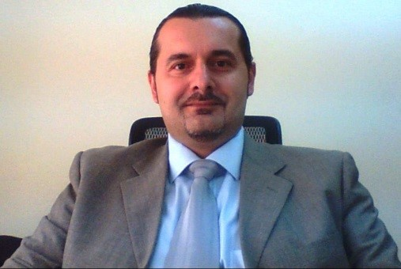 |  | Konstantinos Tsikas (PMP)  Saudi Aramco - Project Management Team (SAPMT)  PROJECT ENGINEER I
Profile  I am a competent, results-driven and dynamic professional (PMI-PMP certified) with an insightful experience of 24+ years, managing MEP projects and currently deployed in Oil & Gas industry under the Project Management Team. Possessing strong expertise in handling diverse activities such as project planning, scheduling, cost-control, resource planning and management.  My OBJECTIVE is to offer a reputation as an adaptable quick learner known to an organization that can benefit from my technical aptitude, ability to effectively train and work well with others, creativity, and experience in Project Management  Contact  PHONE:  +966 5513 31148  WEBSITE:  linkedin.com/in/konstantinos-tsikas-pmp-b4b36234  EMAIL: (Preferred)  kostastsikas@gmail.com  Hobbies  Swimming  Travelling  Cooking |  | EDUCATION  TEI Peiraeus - S.TE.F. - Electrical Engineering  1992 – 1996  Bachelor’s Degree in Electrical Engineering  EPEAEK - Open University of London & TEI Peiraia  2002 - 2004  Post Graduate degree in Management of Energy Systems  Sivitanideios Technical High School - 2nd T.E.L. – Electronics  1988 - 1992  HND in Automation and Industrial Controls - Electronics  WORK EXPERIENCE  Saudi Arabian Oil Co. (Saudi Aramco) – Kingdom of Saudi Arabia  Project Management Team, Project Engineer I  October 2014 – Present  Al Jaber Electromechanical Co. WLL - Qatar  Head Of (MEP) Projects Management Office (HPMO)  June 2011–October 2014  Terna Contracting – Kingdom of Bahrain  Mechanical Electrical Plumbing (MEP) Manager  July 2008–June 2011  G.P. Zachariades (O) Ltd. – Kingdom of Bahrain  Senior Electrical Engineer  June 20016–July 2008  Drosos Techniki Ltd. – Hellas/Greece  Director of MEP Projects  January 2002 – June 2006  Domiki Anaptyksi AVETE  Electrical Engineer / Assistant MEP Manager  January 1998 – January 2002  Hellenic Army Forces – Hellas/Greece  Electrical Engineer  July 1996 – January 1998  SKILLS

