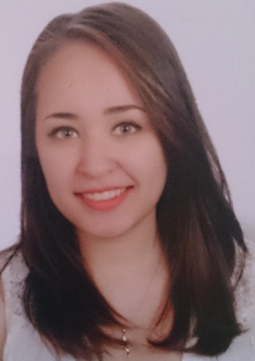

***Objective:***

To work in a position that will allow me to utilize my skills, educational background and knowledge in order to gain more experience and maximize my efficiency and productivity in any given position.

***Personal Details:***

**Full name:** Noor Ali Abdulla Ali Isa

**Nationality:** Bahraini

**D.O.B.:**  September 2nd, 1994

**Contact information:**  +(973)39933266 ,

Nooraaisa@gmail.com

***Education And Qualifications:***

* February 2015: Customer care: (Vision, energy & passion to serve) **Dynamics Training Institute**
* Apr 2011 – Aug 2013: General education development (GED)

**Anne Arundel Community College, Baltimore – USA**

* Sep 2009 – Mar 2011: General Commercial Studies

**Hamad Town Intermediate & Secondary girls’**

**School**

***Employment & work experience :***

* September 2016 – Present: Dental receptionist/ Admin.

**Dr. Mohammed AlOlayyan Orthodontics & Dental Center.**

* May 2014 – August 2016: Dental receptionist.

**Saar dental specialists**

***Skills:***

* **Interpersonal**
* **Bilingual Communication skills:** Efficient in communicating with people from various backgrounds and cultures, while maintaining a high level of professionalism.
* **Team working skills:** Works well as part of a team and excels at exchanging information with team members efficiently and effectively.
* **Presentation skills:** Fairly skilled in presenting information swiftly, accurately, and as to-the-point as possible.
* **Time management:** Can work very well under pressure.
* **Languages**
* **English** – Fluent in writing and speaking.
* **Arabic** – Fluent in writing and speaking.
* **IT**

Well skilled in the use of all Microsoft Office computer applications.

Well skilled in use of IDMS and Open Dental systems.

* **Other**
* A very fast learner with the ability to cope and adapt to different situations and work environments.
* Can analyze and defuse problems and provide workable, realistic and credible solutions.