**Stefan Ryan Fernandes** 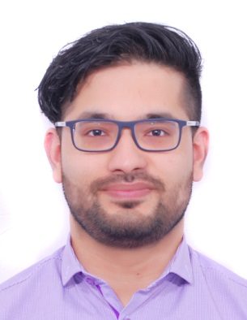

**Flat 13, Bldg 754**

**Road 822, Block 308**

**Gudaibiya**

**Kingdom of Bahrain**

**Contact No. 39143973 / 17231588**

**E-Mail ryanmsd_90@yahoo.com**

**Bio-Data**

|  |  |
| --- | --- |
| Objective | **To attain success by my hard work and dedication and have a stable career in a growing organization that exposes me to a dynamic environment of learning and growth.**  **About Me:**  Dedicated, Result & Goal Oriented person with proven strengths in the field of Customer Service. Demonstrated capacity to multitask: manage numerous, often competing priorities with ease. Strong team player with ability to contribute to identify and evaluate problems through interpersonal and communication skills.  **Skills & Abilities**   * Good communications skills in dealing with customers, co-workers, and employees. Both verbal and written skills are strong. * Well-organized and highly efficient working in a multi-tasking dynamic environment. Ability to plan, organizes and supervises the work of others. * Computer Literate - MS office, Internet, E-mail & Adobe Page Maker   **Linguistic Proficiency**   * **English - Read, Write and Speak** * **Hindi - Read, Write and Speak**   **Hobbies/Interest**  **Swimming, Listening to music, Cricket , Football & Reading**    **Voluntary Experience**   1. **Worked as a volunteer for the Indian school cultural community during the fair.** 2. **Organizer for many seminars and meetings conducted for the commerce stream.** 3. **Participant for many competitions which involved team work and communication skills.**   **I also have Bahraini Driving License** |
| Academic Profile | **Employment:**  **Worked for FK International as Accounts Clerk from 1st February 2018 to March 31st 2020**  **Worked for Rivoli as Sales Associate from 1st June 2011 till 15th December 2017**  **Passed 12th ( CBSE ) in the year 2009 – Indian School in Bahrain**  **Completed Computer Hardware & Advance Networking at Global Institute in Bahrain.** |

**Personal Details**

**Nationality: Indian**

**Date of Birth: 6th January 1990**

**Place of Birth: Kingdom of Bahrain**

**Marital Status: Single**

**Gender: Male**

**Complexion: Fair**

**Height: 6”3**

**Passport No. T 2407118**

**Present Address: P.O. Box 1027**

**Manama, Kingdom of Bahrain**

**Stefan Ryan Fernandes**