Salman Basit



Nationality : Indian

Contact : +973-36201433

Email : [salmanbasit.sb@gmail.com](mailto:salmanbasit.sb@gmail.com)

Skype : salman-basit111

LinkedIn : www.linkedin.com/in/salman-basit-83a19230

***About Me***

Six years mid management level experienced engineering professional with direct work experience in execution and construction developments under following categories such as Firefighting Systems (Dry & Wet), Electrical Systems (Low & Medium Voltage), Building Security & Management Systems such as ICT containments and Fit – Out Construction.

***Profile Summary***

* Competent **Mechanical Engineer** with proven skills in achieving client satisfaction.
* **Total Professional Experience – 5 years & 11 Months.**

***Qualification***

|  |  |  |  |
| --- | --- | --- | --- |
| **Examination** | **College** | **Percentage** | **Board/University** |
| Master of Technology (*Thermal Engineering* ) | Royal Institute of Technology and Science | 70 | JNTU, Hyderabad, India. |

***Current Employment***

* **Project Engineer at Bluescape Civil and Electro Mechanical Services.**

**Year: July 2017 – Present**

***Responsibilities:***

* Serving as a Project Engineer performing duties in support of projects.
* Preparing material estimates, project schedules and reports.
* Reviewing project specifications and preparing the relevant submittals.
* Raising technical queries after reviewing the design if any.
* Thoroughly scrutinizing the project data for possible value engineering.
* Ensuring proper arrangement of materials as per approved submittals and dealing with suppliers.
* Preparing and documenting progress reports, work schedule, manpower planning and coordinating with the main contractor.
* Raising material/work inspections and conducting them alongside QC inspector and documenting them.
* Reporting back to the Project Manager for project related daily reports & site issues.

***Ongoing Project***

* **BAHRAIN INTERNATIONAL AIRPORT MODERNIZATION PROGRAME**

**ICT SECONDARY CONTAINMENT SYSTEM**

**Sub-Contractor: Bluescape Co. W.L.L (Under Almoayed ICT)**

**Role : Site Engineer**

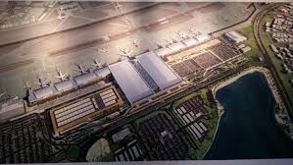***Responsibilities:***

* To lead a team of Supervisors, Electricians, Technicians and helpers ensuring the implementation of the exact technical specifications and the drawings.
* Assigning tasks and responsibilities to members of the team, mentoring the project team and managing its performance.
* Solving the technical issues arising on site in coordination with other disciplines.
* Attending site walks, progress meetings, coordination meetings with the client/consultant and ensuring their requirements are met.
* Ensuring the as-built drawings, progress mapping is updated and forwarding the same for approval.
* Providing the necessary clearance for the inspection requests of other disciplines.
* Monitoring the compliance of the project to ensure that the specifications, method statements and practices are adhered to, quality assurance policies are followed, and performance standards are met.
* Preparing and documenting progress reports, work/look schedule, manpower, tracking sheets, and reports.
* Preparing, documenting and discussing safety issues and updates to site teams and concern authorities.
* Reporting back to the project manager/head office for project related concerns.

***Projects Completed***

1. **The Avenues – Kingdom of Bahrain.**

Role: Mechanical Engineer.

Consultant: Arab Architects.

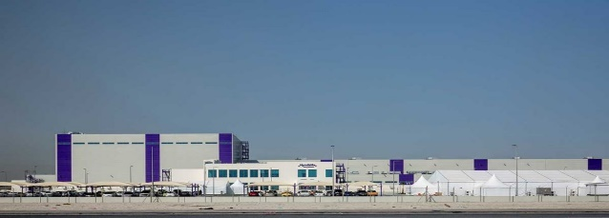

1. **Mondelez International, Salman Industrial City,**

**Kingdom of Bahrain.**

Role: Mechanical Engineer.

Consultant: Bilfinger Tebodin BV.

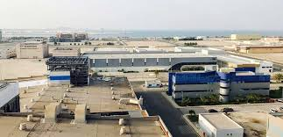

1. **CPIC – AFG, Salman Industrial City,**

**Kingdom of Bahrain.**

Role: Site Engineer.

Consultant: Aref Sadeq Design Consultant.

1. **TISCO – Republic of India,**

Duration: June 2014 – Oct 2016.

Role: Site Engineer.

***Previous Experiences***

* Mechanical Engineer at NAYZAQ Group, Bahrain.

Year: 2016 – 2017 (1 year)

* Site Engineer at Monty Enterprises, Jamshedpur, India.

Year: 2014-2016 (2.5 years)

***Certifications and Licenses***

* Vocational Course on Auto-Cad from Central Institute of Tool & Design (CITD), Hyderabad certified by the government of India.
* Received training on Industrial Maintenance and safety from Advanced Training Institute (ATI), Hyderabad certified by the government of India.
* Certified NDT Level II in MT, PT, RT & UT having Credential ID MSIE/PT/1510.
* Bahraini Driving license valid till Dec 2022.

***Technical Skill***

|  |  |
| --- | --- |
| AutoCAD, Mechanical Drawing | Quality Control |
| MEP Coordination | Project Management (Aspirant) |
| Procurement of Mechanical Accessories | Computer Proficient (Microsoft Suites) |

***Interpersonal Skills***

* Positive attitude
* Instant planning
* Active listener
* Team Player
* Effective Communication
* Hard working
* Responsible

***Personal Information***

|  |  |  |  |
| --- | --- | --- | --- |
| Father’s Name: | Mannan Ahmad | Date of Birth: | 29th May, 1989 |
| Religion: | Islam | Marital Status: | Single |
| Languages known: | English, Hindi and Urdu | Driving License | 890564620 |

In view of above, I request you to give me an opportunity to serve your esteemed organization in the capacity mentioned above for which I shall be very thankful to you.

Salman Basit