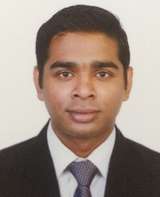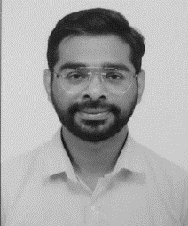**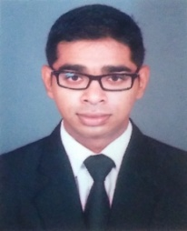Titto Thomas**

**Date of Birth** :- 8th June 1991

**Gender**  :- Male

**Marital status** :- Unmarried

**Contact Number** :- 34110364

**Languages :-** English, Malayalam, Hindi, Marathi

**Email Id**  :- [tthomas126@gmail.com](mailto:tthomas126@gmail.com)

**Objective:-**

**Physically fit, customer oriented with excellent communication skills. I believe my training will contribute to the success of the events your esteemed company is known for.**

**Career Preface: -**

1. **Meshal Hotel, New Vision Group, Bahrain**

Role – Coffee Shop Incharge

13 November 2018 till present

* Maintaining the coffee machine.
* Making the coffee according to the guest needs.
* Maintaining inventory and replenishing the material.
* Preparing the duty roster.
* Maintaining the cash register.

1. **Grand Hyatt Mumbai**

Role – Event Coordinator / Event Planning

1st September 2017- 6th March 2018

* Taking the guest requirements for the event and coordinating with departments in the hotel.
* Trying to upsell the rooms and function halls.
* Preparing the event flow for the event.
* Opening of the posting master to post the advance payment.
* Ensuring the smooth flow event on the function date.
* Collection of the final payment before or after the event is done.
* Making connections for the future events.

1. **Grand Hyatt Mumbai**

Role – Banquet Waiter

19th October 2015 – 31st August 2017

* Preparing the function hall before the event according to the guest requirements given in the event flow.
* Working as the butler for the host of event and shadowing him/her for their additional requirements and coving the requirements to managers.
* Informing the managers for the changes in function flow.
* Setting up the bar and liqueur before the event and taking approval from the guest.
* Showing the final bill to guest and doing the settlement according the event flow and convey it to the manager.

**Education Preface: -**

1. 2013 - 2015 Bachelor of Science (Hospitality Studies And Catering Services) from Yashwantrao Chavan Maharashtra Open University, Nashik
2. 15th November 2013 – 28th February 2015 - Internship for 3 months in Food Link
3. 2012 - 2013 Cookery from Maharashtra State Board Of Vocational Examinations
4. 01st May 2012 - 31st August 2012 - Internship for 4 months in Renaissance Mumbai Convention Centre Hotel

**Computer Proficiency: -**

Outlook Express to communicate in Department

1. **Envision** sales for understanding the booking status of the rooms and event halls
2. **Opera** to understand the rooms status and guest details
3. **Iscala** to work on the inventory management software

**Skills: -**

1. Administrative skills
2. Training skills
3. Fast learner

**Strength: -**

1. Guest Relation
2. Team Player

I hereby declare that all the above-mentioned details are true to my knowledge

Thanks, and warm Regards

Titto Thomas