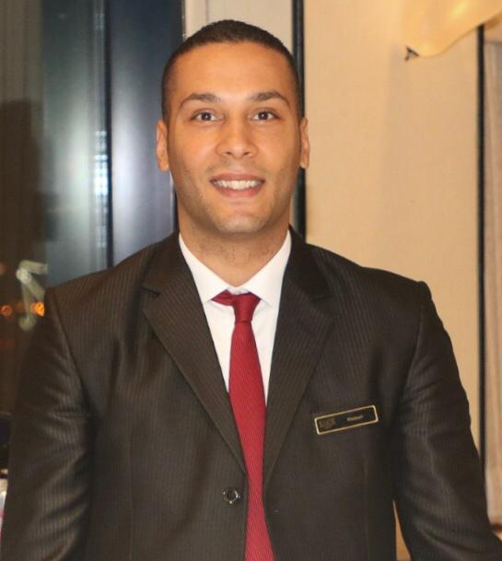**Hassan Hamdy Hasseen Mohamed**

*Address*: Al Manama - Kingdom of Bahrain

*Contact Number:* +973 33632837

*Email Address:* [hassan.hamdy.hussain@gmail.com](mailto:hassan.hamdy.hussain@gmail.com)

**JOB OBJECTIVES:**

A career opportunity to develop my skills and enhance my capabilities, as well as providing creative or innovative services to clients to the best of my abilities. In addition, it will give me an opportunity to grow as an individual and it will develop my capacities physically, mentally, emotionally and socially; there by, improving myself and my relationship with others

**WORKING EXPERIENCE:**

**ELITE HOSPITALITY GROUP - Manama, Kingdom of Bahrain**

**Captain** (May 2015 to present)

**RESORT HOTEL - Sharm El-Sheikh, Egypt**

**Waiter** (April 2010 – December 2014)

**Responsibilities:**

* Greeting and welcoming guests to the hotel and showing to a free table.
* Acting as a source of information to the guests about our services as well as our products.
* Operate the telephone by connecting international and external calls to different

Departments

* Check-in with guests to ensure that everything is going well.
* Take necessary action to resolve any complaints.
* Taking guests orders and bringing them to the concern sections.

**SKILLS AND ABILITIES:**

Can easily understand instruction and work under minimum supervision.

Hardworking, trustworthy and reliable.

Produce work that is orderly and attractive.

Ensure tasks are completed correctly and pass on time.

Willing to try new things and interested in improving effiency on assigned task.

Flexible with regards to time.

Loyal and can be trusted by the company.

Can speak and understand English.

Basic computer proficiency.

Has basic knowledge of alcohol beverage mixing cocktails and mocktails.

Professional and friendly.

Team player.

Well motivated with ability to function effectively in a team.

**EDUCATIONAL BACKGROUND**

**Education/Training**

2009-2012:

Certificate of General Secondary Education

Profession: Industrial Diploma – Air condition technician

2006-2009: Egyptian Basic Education Completion Certificate

2000-2006: Egyptian Primary School Certificate

2010 Cross training in hotels academy (food & beverage service) .

**PERSONAL PROFILE**

Nickname: Hassan

Height: 5’11”

Weight: 78 kg

Nationality: Egyptian

Date of Birth: 20th November 1993

Gender: Male

Marital Status: Single

Languages: Arabic and English

Age: 26 years old

Driving License Valid Bahraini Driving License

**For reference:**

Mr.: **Jumah Raheem**

Superintendent Terminal Catering

Bahrain airport services

E-Mail:    [jumah.raheem@bas.com.bh](mailto:jumah.raheem@bas.com.bh)

Mobile: + 97337722561

*I hereby certify that the above information are true and correct to the best of my knowledge.*