*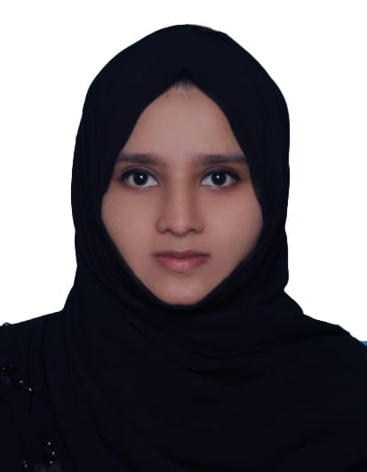***FATHIMA MOL K**

*Applied Electronics and Instrumentation Engineer*

*Mob: +973 38810309*

*Email:* [*fathimafahad2019@gmail.com*](mailto:fathimafahad2019@gmail.com)

*Bahrain Driving License holder.*

**OBJECTIVE**

Committed and highly skilled instrumentation engineer familiar with standard controls and Instrumentation requirements.  Strong management and leadership abilities for delegating tasks or providing instruction clearly and accurately. Prioritizes attention to small details to ensure problems are resolved before they impact production or cause a safety hazard.

**WORK EXPERIENCE**

* **Electronics & Instrumentation QC Engineer**

#### **Tecnicas Reunidas at Yokogawa Middle East & Africa, Bahrain. (Dec 2019 - Present)**

**Technical Skills & Duties Performed**

* Currently working as a QC engineer for *DUQM Refinery Project* ***EPC Package – 1.***
* Familiarized the Yokogawa Centum, Pro Safe software for DCS, ESD Cabinets.
* Familiarized the Yokogawa IO Cards and its trouble shooting activities.
* Perform the simulation test for each IO signals with respect to IO card.
* Hardware Inspection for DCS, ESD, PDC, FGS, BMS, NSC & CCB Cabinets (EPC PKG#1) according to the ARAMCO IES, SAMSS, SAES and other Standards.
* As per FAT procedure, Perform Loop checking for Analog Input /Output and Digital Input and output with required Multi Meter and Calibrator.
* Create FAT Punch points/Comments related to each Cabinets as per SAMSS (Indoor and Outdoor) and give Proper recommendations to clear the punches to vendor.
* Review the FAT Procedures and Check list while performing FAT activities.
* Functional Test/Power on Check of the related Cabinets as per FAT procedure.
* Visual Inspections with vendor for DCS/ESD System Cabinets, Analog /Digital Marshalling Cabinets, Analog/Digital Component Cabinets, FGS, BMS, CCB, Network and Server Cabinets.
* Witness the Insulation resistance test in PDC Cabinets.
* Monitor, Coordinate and update the all work in progress.
* Review and analyze the Detailed Layout Drawing, Wiring Diagram, Bill of Materials and all type of documents.
* **Instrumentation QC Engineer (March 2019 – Dec 2019)**

**Delta Gulf WLL, Bahrain**

**Technical Skills & Duties Performed**

* Worked as a QC engineer for *DUQM Refinery Project* ***EPC Package 2.***
* Carried out Vendor and Third party inspection for the process control system which includes DCS, FGS, and BMS, CCB, NSC and ESD systems at Vendor facilities.
* Witnessed PIM in process, Pre-FAT / FAT for the Process Control System.
* Witnessed Inspections for the system readiness review, Visual Inspection, Electrical, Power connection, wiring check, DCS system hardware functionality check, DCS configuration, Loop & spares check , Historian and Report check, Failure mode, Foundation field bus functional checks, Network Configuration, Hardware functionality checks, System management and workstation verification, FAT completion record and Packing test.
* Review of inspection and Test plan with upmost accuracy and adherence to the stringent timelines.
* Material verification as per the applicable standards, Functional testing in all stages of inspection in accordance with clients specification and requirements, ITP and international standards
* **Instrumentation Engineer – (Oct 2017– Feb 2019)**

**IPCS Automation, Calicut, India**

**Technical Skills & Duties Performed**

* Ladder Logic Programming mainly Allen Bradley, ABB, Keyence, Siemens.
* Assist in design and development of user interface functionally and the implementation of workflow rules.
* Develop and maintain standardized work problems for PLC, testing and automated equipment.
* Project Coordinator with other field Engineers, Coordinating printing, presentation and administration procedures.
* Familiar with SCADA Software – Intouch, Wonderware.
* Knowledge of panel view programming.
* Excellent attendance and performance record.
* Provide recommended scope of work for projects and assist in implementing approved system changes.
* Ability to meet reliability, performance, cost, serviceability and delivery targets.
* Work comfortably with field personnel.

**EDUCATION**

**2017 Bachelor of Technology/Engineering – 73%**

Applied Electronics and Instrumentation Engineering

M.E.S College of Engineering, Calicut University

Kuttippuram, Kerala, India.

**2012** **Secondary School - 84%**

Rani Public School, CBSE, Vadakara, Kerala, India.

**2010** **Senior School – 82%**

**CERTIFICATIONS**

**2017**  **Diploma in Industrial Automation Engineering**

(PLC, SCADA, VFD, CONTROL PANEL)

IPCS Automation, Calicut, Kerala, India.

**INTERNSHIPS**

**INDUSTRIAL TRAINING**

**FACT (Fertilizers and Chemicals Travancore Limited)**

An industrial training at FACT, Cochin, Kerala, India.

**INDUSTRIAL VISIT**

**Kozhikode Diesel Power Plant**

KOZHIKODE DIESEL POWER PLANT, Nallalam, Kozhikode, Kerala, India.

**TECHNICAL SKILLS & SUBJECTS OF INTERESTS**

* **Instrumentation & electrical**
* PLC Programming specific to Allen Bradley, ABB, Keyence, Siemens, Delta (Trained – certified).
* SCADA–Wonderware (Trained – Certified).
* SCADA Programming - Intouch, Monitoring, Interfacing with PLC, Troubleshooting.
* **Management Tools**

* Proficient in Microsoft Office Suite particularly Word, Excel & PowerPoint.
* Excellent management skills and the ability to prioritize workload.
* Highly motivated and a good team player.

**PERSONAL PROFILE**

**Date of Birth** : 07th January, 1995

**Gender** : Female

**Nationality** : Indian

**Languages Known** : English, Hindi, and Malayalam