Sr.HSE Officer
Resume

2022
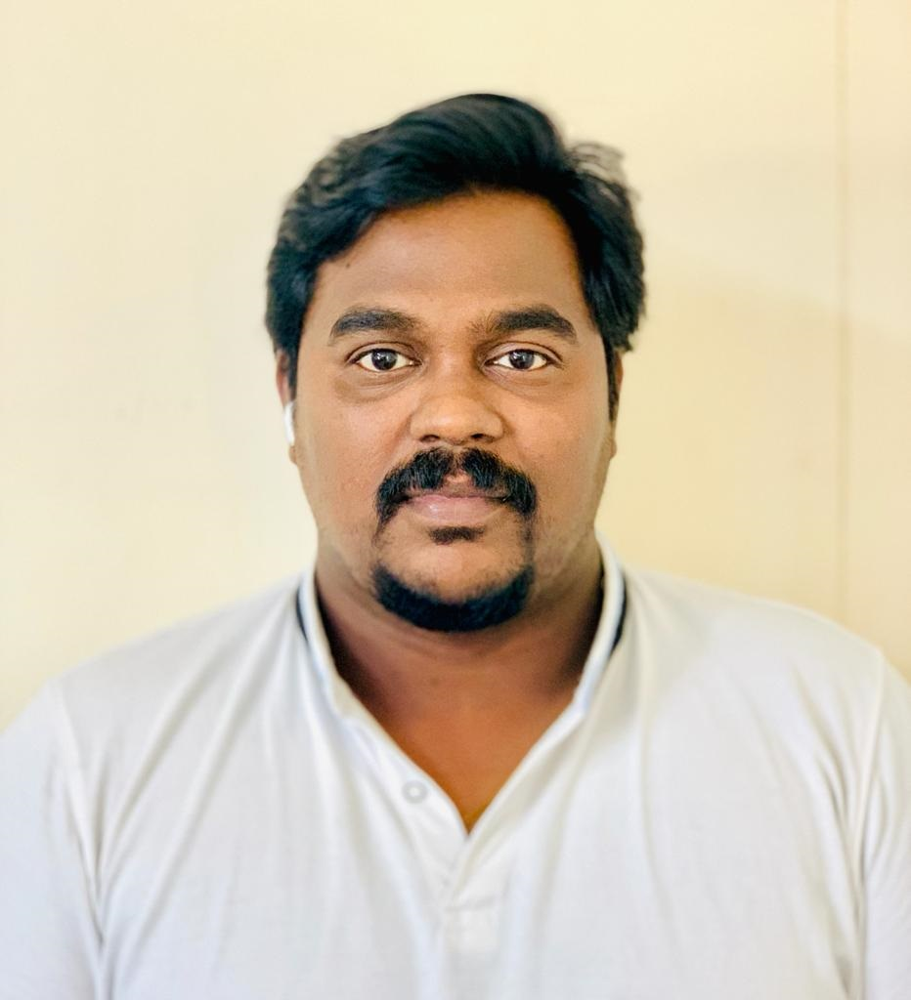

Sub: Sr. Health & Safety Officer - BAHRAIN

Safe Day,

My self Harirag R Pillai working with an international leading company in Bahrain. I have 12 years’ experience in civil and maniacal construction field including Oil and Gas plant safety. I am a BSC I Dip & NEBOSH certificate holder and achieved certifications from OSHA, First Aider, Diploma in computer application, Fire & safety engineering diploma and a participant in many HSE training sections held by leading company’s and third parties. Now I would like to upgrade my carrier by working with an esteemed organization to achieve a better financial and carrier growth.

Hope you will consider my application for the post in your estimated organization, please review my CV attached with this mail for more details.

Thanks & Regards

HARIRAG R PILLAI
HSE Officer
Mobile: +973-337 45550
harirag10@gmail.com

973

HARIRAG R PILLAI
+973 3374 5550 | harirag10@gmail.com
Profile
.
A motivated, experienced and committed HSE PROFESSIONAL who is goal orientated and has a consistent track record of achieving the highest standards in safety. Fully committed to Health & Safety management and having a proven ability to effectively evaluate, organize priorities risks and work within an overall project schedule. Hard working disciplined and an excellent communicator who can get along with both colleagues and senior managers. Currently looking for a challenging position in a well reputed organization.
Core Skills
- Microsoft office
- Diploma in Computer Application (C-ACE 2008, India)
- Training program implementation on different HSE topics
- Bahrain Ministry certified First Aider
- Bahrain Ministry Certified Fire Fighter
- Trained for making and implementing risk assessment
- Bahrain Driving License Holder
Professional & Academic Educational Qualification
- NEBOSH International General Certificate U.K (2013, India)
- Diploma in FIRE & Safety Engineering. (NIFE 2008 Batch India, Kerala).
- OSHA Certification (2008, India)
- Red Cross First Aid Certification (2008, India)
- STC Bahrain Certified First Aider (2016)
- Emergency First Aider from TUV Middle East (2019 Bahrain)
- Scaffolding Inspector from Bureau Veritas (2019 Bahrain)
- Scaffolding Inspector from TUV Bahrain (2022 Bahrain)
- Diploma in Computer application (C-ACE 2008, India)
- Higher Secondary (HSE board, India, Kerala)
- SSLC from Kerala State Secondary Education Board. (India)

Training Attended
- HSE TRAINING
- JSA (Job Safety Analysis)
- Authorized Permit to Work Certificate (Tatweer petroleum)
- Hot work Training Course (ESSAR Oil Ltd)
- Scaffold, Working at Height and Ladder Safety Training Course. (ESSAR Oil Ltd)
- Confined Space Training Course. (ESSAR Oil Ltd)
- Lock out tag out system (LOTO) (ESSAR Oil Ltd)
- First Aid and firefighting course (ESSAR Oil Ltd
Company | Position | Year | Project | Client | Consultant
 |  | Duration
Metal Crafts Constructers PVT LTD  (MECHNICAL COMPANY) | HSE Officer | 2010-2013 | Refinery expansion projects | ESSAR Oil INDIA LTD | THERMAX
 |  |  | 2 X 320 MW Power plant project
Mechanical Shutdowns
- Crude distillation unit(CDU)
- Vacuum distillation unit(VDU)
 |  |  | Delayed cocker unit(CDU)
 |  |  | Petrol Chemical Plant mechanical maintenance and scaffolding
Poullaides Construction company. W.L.L | HSE Engineer | 2013-2014 | Tatweer petroleum office building project  New central control facilities office building | Tatweer petroleum | DTEB
Poullaides Construction company. W.L.L | HSE Engineer | 2015 | Bahrain Kuwait embassy office building | Kuwait embassy | ETEC
Poullaides Construction company. W.L.L | HSE Engineer | 2015- 2016 | Almarai Bahrain Sales Depot | Almarai | Tebodin
Poullaides Construction company. W.L.L | HSE Engineer | 2016- 2017 | Diyar Al Muharraq Al Oyoun Project | Ministry of Housing | MottaMac Donald & HAJ
Poullaides Construction Company. W.L.L | HSE Engineer | 2017- 2017 Sep | ALBA Pot Line Project | ALBA | Bechtel
Havelock One Interiors WLL | HSE Engineer | 2017 Sep – Till Now | Avenues Mall – Bahrain | Mabani
 |  |  | City Center – Bahrain | Majid Al  Futtaim
 |  |  | New Bahrain Airport | Bahrain  Airport Company
 |  |  | BDF at Riffa | Ministry  of interior
 |  |  | National Bank of Bahrain | NBB | PSC
 |  |  | Hilton Garden Inn | Bariq Al Retaj | SSH  DWP
 |  |  | VOX cinemas at Avenues Mall | VOX
 |  |  | Magic Planet at Avenues Mall | Majid Al  Futtaim
 |  |  | Al Areen Villa Project | Al Areen | Infracorp & IDA

Professional Experience

12 years’ experience in HSE functions varies oil & gas projects, mechanical and civil projects in inside and outside Petro chemical refinery areas, Refinery maintenance and major Petro chemical shutdown projects.
Carrier Summery
- Total 12-year experience in CONSTRUCTION, MAINTENANCE, and SHUTDOWN in oil & gas and Power projects.
- Leadership in planning and scheduling activities and skills in problem solving.
- Experience in collect and interpret the new /old legal regulations and interpretations to the management with respect to the HSE.
- Good understanding and implementation of organization safety policy and its implementation up to the bottom of the workforce.
- Implementation of safe system of each activity in compliance with organization safety manual or plan.
- Responsible for generating plant and equipment inspection and its documentation and reporting.
- Conducting & monitoring safety talks, safety bulleting as well as safety alerts.
- Preparation of documents as per the requirements of client/ consultant as well as keeping and updating reports of man-hours, LTI, accidents, incidents and safe man hours.
- Preparation of monthly and weekly HSE performance reports.
- Daily observation reporting and hazard identification and take immediate actions and solutions.
- Implemented internal audit system by conducting drills as well as routine checks for ensuring compliance and consistency in the work site.
- Conducting periodically fire drills, fire training and arrangements for targeted safe man-hours celebrations.
- Ensuring the work efficiency of the safety equipment from time to time.
- A team player, dependent and highly motivated induvial who can able to work independently.
- Experience of performing the risk assessment and conducting the test drills to ensure the alertness.
- Conducting the staff training with ability to guide them for the safety measures
- Excellent communication skills with a good relationship with the management and the employees.
- Self-motivated and Can do work any circumstances.
- Able to review and update the HSE policy and plan upon changes.
- Able to investigate accident incident cases.
- Two external agencies certified first aider with experience to handle any situation.
- Experience in conducting safety meeting, toolbox talk, and safety orientation program and safety presentations.
- Developing and implementing new engineering and administrative hazard control system.
- Having good languages skills.

Nature of Job

Job involved was Responsible for scheduling and planning of all safety related matters for Project. Implementing HSE Policy, Coordinating Safety personnel for all civil, Piping, Structure, Heater & boiler fabrication & erection activities of 32 MMTPA Refinery Expansion, planning all types of maintenance activities such as preventive, corrective and shutdown safety. Work experience in largest refinery complex ESSAR OIL LIMITED’S major hydrocarbon plants such as CDU/VDU, FCCU, DCU, VBU etc. Carried out Two Major Shutdowns. Coordinating with the superiors in preparing reports, and specifications and reduce any unwanted incident causing potential safety risks.
Personal Details

Age & date of birth : 31, 17.05.1990
Nationality : Indian
Marital status : Married
Languages known : English, Hindi, Malayalam, Tamil
Contact : +973 33745550
Email : harirag10@gmail.com

Passport Details

Passport No : T 2409334
Date of issue : 25.03.2019
Date of expiry : 34.03.2029
Declaration
I do hereby declare that the above-mentioned details are true to the best of my knowledge and belief.
Thanking You.
Yours truly, HARIRAG RAJAN PILLAI

