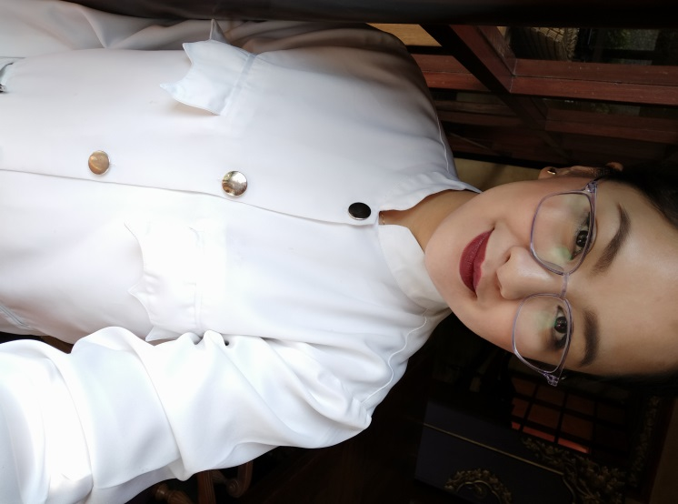

**Ivy Cortez Gonzales**

BLDG 243 Road 3605 Block 336, Manama, Bahrain

Email Address: ivycortezgonzales@yahoo.com

Contact Number: 39408753

_____________________________________________________________________________________

**Objective*:*** To work in a company wherein I can apply my skills and knowledge to be able to serve the company with the highest possible excellence.

_____________________________________________________________________________________

**WORK EXPERIENCE**

**Fontana Leisure Parks**

Clark Field Pampanga, Philippines

**Position:** Front Desk Finance Cashier

August 2015 – December 2016

**Job Responsibility**

• Responsible in receiving cash and card payment of customers including issuance of Official Receipts.

• In-Charge of ticket reservations for waterpark facility.

• Received and logged cash remittances from casino.

• Prepared daily summary of cash and credit transactions.

• Attend to guests’ enquiries regarding discounts, memberships and reservations related to waterpark and restaurants.

• Processed membership payment receipts to customers.

**Maharaja Hotel**

Angeles City, Pampanga Philippines

**Position: Receptionist** July 2011 – January 2013

**Job Responsibility**

• First point of contact in providing information regarding the hotel and assist the guests to the registration desk.

• Take phone calls and forward to appropriate departments or persons. • Answered telephonic and in-person queries related to hotel services

• Assisted guests’ in storing valuables in secured deposit boxes.

• Provided administrative tasks such as photocopying, scanning, sending/receiving fax, dispatching/receiving postal and courier mails.

• Maintained office supplies and received delivery items

**AL GHALIA**

Manama, Bahrain

**Position: Cashier** February 04 2018 up to Present

**Job Responsibility**

* Maintained a cheerful, friendly attitude towards customers while correctly operating the cash register.
* Handled purchases in cash, credit cards, and ATM debit per company policy.
* Performed other duties as assigned my Manager.
* Posted checks, Balanced daily checks and sales reports
* Entrusted with handling money in the restaurant
* Maintained the highest quality of customer service by anticipating the needs of each individual guest

**COMPUTER SKILLS:**

Knowledge in Computer Assembly, Troubleshooting, Networking, and Interfacing,

Proficient in Excel, Word, Power Point and Outlook

**EDUCATIONAL BACKGROUND:**

**Computer Science – Associate of 2 Year Programming**

Clark College of Science and Technology

Dau, Mabalacat Pampanga

(2013 – 2015)

**Personal Background:**

**Date of Birth**: July 12, 1990

**Civil Status**: Single

**Nationality**: Filipino

**Visa Status:** Working Visa

**References:**

Available upon request